

**CMPE 273 – 02: ENTERPRISE DISTRIBUTED SYSTEMS**

**Project Report**

**UBER Cab Service**

**Submitted To:**

Prof. Simon Shim

**Date of Submission**

Dec 2nd 2015

**Submitted By**

Team 10

|  |
| --- |
| Team Members |
|  |
| **AISHWARYA PATWARDHAN** |
| **APOORV PATEL** |
| **SHAGUN JUNEJA** |
| **SNEHA JAIN** |
| **VISHWAS MUKUND** |
| **WAAD JARADAT** |

**PROJECT ARCHITECTURE**

In this project the Client is developed using the MEAN stack that is MongoDB, Express.JS, AngularJS and NodeJS. Express.JS handles the server and the routing. On the Server side the Node.JS server returns the results from the MySQL database to the RabbitMQ Message passing service, which returns the response to the client. MongoDB is also used to store and display certain type of data to get the full advantage of its advanced NoSQL Features. Google maps APIs has been extensively used to generate

**Description of components in application DB Schema/strategy**

**Customer**

Any User can add himself. He can sign up by just his basic credentials. Once he logs into the system he can view driver which are available near his area. View driver's profile (view heir rating, their advertisement, car model car number etc.).The user can also Request Ride, View History and view the bill of each ride. The user table in the database not only has a full description of the user like first name, last name address email and password but also the credit card is stored securely. The password field is hashed to improve security. The customer has the ability to delete his own account.

**Driver**

The driver can sign in, or become a member of the service using the sign up. The admin can add or remove a driver also. The driver after logging in can accept the Ride initiated by the user, View History and view the bill of each ride. The password field in the driver table is hashed to improve security. The driver has the ability to delete his own account.

**Billing**

Billing module has dependencies with customer, driver and ride tables in the database. So when a user requests a ride and after the completion of the ride a bill is generated with the following attributes date, start location, end location, userid, driverid , rideid and amount and distance travelled with. The billing is based on a pricing algorithm which varies the cost of the ride with factors like time and availability.

**Rides**

The Rides module contains all the essential information in a ride, Ride ID is used as the primary key ,It stores the time also it keeps track of start and end locations of each ride and also it is dependent on customer and driver tables. So 1 customer requests a ride which is handled by a single driver which has a single ride ID.

**Admin**

The admin of the Uber system can create a user or a driver, view bills, and view admin reports which is statistical data representing many factors like which area has most ride requests and revenue reports. The admin can search for a particular user or driver or a bill report. The admin has the power to delete the user or a driver.

**Entity Relationship Diagram –DB SCHEMA**

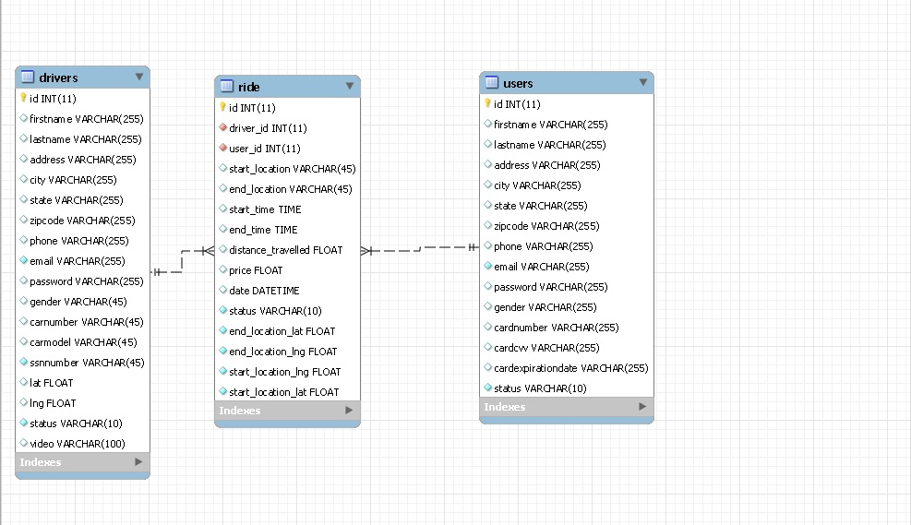

**DB Script**

**Users Table script**

-- MySQL dump 10.13 Distrib 5.6.24, for osx10.8 (x86_64)

--

-- Host: 127.0.0.1 Database: uber

-- ------------------------------------------------------

-- Server version 5.6.26

/*!40101 SET @OLD_CHARACTER_SET_CLIENT=@@CHARACTER_SET_CLIENT */;

/*!40101 SET @OLD_CHARACTER_SET_RESULTS=@@CHARACTER_SET_RESULTS */;

/*!40101 SET @OLD_COLLATION_CONNECTION=@@COLLATION_CONNECTION */;

/*!40101 SET NAMES utf8 */;

/*!40103 SET @OLD_TIME_ZONE=@@TIME_ZONE */;

/*!40103 SET TIME_ZONE='+00:00' */;

/*!40014 SET @OLD_UNIQUE_CHECKS=@@UNIQUE_CHECKS, UNIQUE_CHECKS=0 */;

/*!40014 SET @OLD_FOREIGN_KEY_CHECKS=@@FOREIGN_KEY_CHECKS, FOREIGN_KEY_CHECKS=0 */;

/*!40101 SET @OLD_SQL_MODE=@@SQL_MODE, SQL_MODE='NO_AUTO_VALUE_ON_ZERO' */;

/*!40111 SET @OLD_SQL_NOTES=@@SQL_NOTES, SQL_NOTES=0 */;

--

-- Table structure for table `users`

--

DROP TABLE IF EXISTS `users`;

/*!40101 SET @saved_cs_client = @@character_set_client */;

/*!40101 SET character_set_client = utf8 */;

CREATE TABLE `users` (

`id` int(11) NOT NULL AUTO_INCREMENT,

`firstname` varchar(255) DEFAULT NULL,

`lastname` varchar(255) DEFAULT NULL,

`address` varchar(255) DEFAULT NULL,

`city` varchar(255) DEFAULT NULL,

`state` varchar(255) DEFAULT NULL,

`zipcode` varchar(255) DEFAULT NULL,

`phone` varchar(255) DEFAULT NULL,

`email` varchar(255) NOT NULL,

`password` varchar(255) DEFAULT NULL,

`gender` varchar(255) DEFAULT NULL,

`cardnumber` varchar(255) DEFAULT NULL,

`cardcvv` varchar(255) DEFAULT NULL,

`cardexpirationdate` varchar(255) DEFAULT NULL,

`status` varchar(10) NOT NULL,

PRIMARY KEY (`id`),

UNIQUE KEY `email_UNIQUE` (`email`)

) ENGINE=InnoDB AUTO_INCREMENT=8 DEFAULT CHARSET=latin1;

/*!40101 SET character_set_client = @saved_cs_client */;

--

-- Dumping data for table `users`

--

LOCK TABLES `users` WRITE;

/*!40000 ALTER TABLE `users` DISABLE KEYS */;

INSERT INTO `users` VALUES (1,'Apoorv','Patel','Esplanade','San Jose','California','95112','8000008065','apoorv@gmail.com','$2a$10$EXM1.Agtg3q7ZU7xOrN7PuSDubhJ/uj.46c/5lynpRIzGyQlThU2G','Male','778844559','477','undefined','AVA'),(2,'Jenny','Lenon','1207 Domain Apt','Santa Clara','CALIFORNIA','95054','4088590060','jenny@gmail.com','$2a$10$8o9ato8trshRbRh8ryjrUuC7lSetNoxrb/3QwTIy.EtDXWdAI6bd.','Female','4444-3333-2222-1111','123','undefined','AVA'),(3,'Joey','Gladstone','1207 Domain Apt','San Jose','CALIFORNIA','95051212','4088590061','joey@gmail.com','$2a$10$K292ItyfkM3g2.mhZtG4Qex.cVSrXTeCItwLAMaY84jVSIW899cjy','Male','1111222211112221','121','12/12','AVA'),(4,'jojo','joe','120 Vista club circle','Santa CLara','Ca','95054','4088590643','joe@gmail.com','$2a$10$p753LI.AckI8SmXNVeYg9eWLHsksJE8laaQrjB/Rrr0h5.99hVlz.','Male','1231090909090','221','undefined','DEL'),(5,'sdjk','as,nmb','n ,sdnjk','sndbk','nd vskd','undefined','8787','db@gm.lk','$2a$10$3VF.I0vpXGarmE7PVjuuRe0DXs2HuuEaY85xuWPv.Rrdj7E65vwee','male','8978060860868608','776','undefined','AVA'),(6,'nfxjfq','gfhmf','jvj,h','jvgjkhv','ca','66666','765868658765','cmghc','$2a$10$qDN82fQAVq0TpRZje0dg/On6AHoAlrcopSy1psbxTsNKT3dT06U3y','fgcmhgcm','gcjgdkg','88m','undefined','AVA'),(7,'Sneha','Jain','San Jose','san jose','California','95191','4088590643','snehajain2210@gmail.com','$2a$10$f3wn14m6x4xUdY3z.0JhLujLsmJqf1wpHIRu5z7931h77I./TOOZm','male','1111222233334444','221','undefined','AVA');

/*!40000 ALTER TABLE `users` ENABLE KEYS */;

UNLOCK TABLES;

/*!40103 SET TIME_ZONE=@OLD_TIME_ZONE */;

/*!40101 SET SQL_MODE=@OLD_SQL_MODE */;

/*!40014 SET FOREIGN_KEY_CHECKS=@OLD_FOREIGN_KEY_CHECKS */;

/*!40014 SET UNIQUE_CHECKS=@OLD_UNIQUE_CHECKS */;

/*!40101 SET CHARACTER_SET_CLIENT=@OLD_CHARACTER_SET_CLIENT */;

/*!40101 SET CHARACTER_SET_RESULTS=@OLD_CHARACTER_SET_RESULTS */;

/*!40101 SET COLLATION_CONNECTION=@OLD_COLLATION_CONNECTION */;

/*!40111 SET SQL_NOTES=@OLD_SQL_NOTES */;

-- Dump completed on 2015-12-02 12:49:21

**Ride Table Script**

-- MySQL dump 10.13 Distrib 5.6.24, for osx10.8 (x86_64)

--

-- Host: 127.0.0.1 Database: uber

-- ------------------------------------------------------

-- Server version 5.6.26

/*!40101 SET @OLD_CHARACTER_SET_CLIENT=@@CHARACTER_SET_CLIENT */;

/*!40101 SET @OLD_CHARACTER_SET_RESULTS=@@CHARACTER_SET_RESULTS */;

/*!40101 SET @OLD_COLLATION_CONNECTION=@@COLLATION_CONNECTION */;

/*!40101 SET NAMES utf8 */;

/*!40103 SET @OLD_TIME_ZONE=@@TIME_ZONE */;

/*!40103 SET TIME_ZONE='+00:00' */;

/*!40014 SET @OLD_UNIQUE_CHECKS=@@UNIQUE_CHECKS, UNIQUE_CHECKS=0 */;

/*!40014 SET @OLD_FOREIGN_KEY_CHECKS=@@FOREIGN_KEY_CHECKS, FOREIGN_KEY_CHECKS=0 */;

/*!40101 SET @OLD_SQL_MODE=@@SQL_MODE, SQL_MODE='NO_AUTO_VALUE_ON_ZERO' */;

/*!40111 SET @OLD_SQL_NOTES=@@SQL_NOTES, SQL_NOTES=0 */;

--

-- Table structure for table `ride`

--

DROP TABLE IF EXISTS `ride`;

/*!40101 SET @saved_cs_client = @@character_set_client */;

/*!40101 SET character_set_client = utf8 */;

CREATE TABLE `ride` (

`id` int(11) NOT NULL AUTO_INCREMENT,

`driver_id` int(11) NOT NULL,

`user_id` int(11) NOT NULL,

`start_location` varchar(45) DEFAULT NULL,

`end_location` varchar(45) DEFAULT NULL,

`start_time` time DEFAULT NULL,

`end_time` time DEFAULT NULL,

`distance_travelled` float DEFAULT NULL,

`price` float DEFAULT '0',

`date` datetime DEFAULT NULL,

`status` varchar(10) NOT NULL,

`end_location_lat` float NOT NULL,

`end_location_lng` float NOT NULL,

`start_location_lng` float NOT NULL,

`start_location_lat` float NOT NULL,

PRIMARY KEY (`id`),

KEY `driver_id` (`driver_id`),

KEY `user_id` (`user_id`),

CONSTRAINT `ride_ibfk_1` FOREIGN KEY (`driver_id`) REFERENCES `drivers` (`id`),

CONSTRAINT `ride_ibfk_2` FOREIGN KEY (`user_id`) REFERENCES `users` (`id`)

) ENGINE=InnoDB AUTO_INCREMENT=53 DEFAULT CHARSET=latin1;

/*!40101 SET character_set_client = @saved_cs_client */;

--

-- Dumping data for table `ride`

--

LOCK TABLES `ride` WRITE;

/*!40000 ALTER TABLE `ride` DISABLE KEYS */;

INSERT INTO `ride` VALUES (8,14,2,'150 E San Fernando St, San Jose, CA 95112, US','32963-33730 N Gantzel Rd, San Tan Valley, AZ ',NULL,NULL,NULL,0,NULL,'CAN',33.1773,-111.547,-121.885,37.3355),(12,15,3,'125 Paseo De San Antonio Walk, San Jose, CA 9','1675 Lincoln St, Santa Clara, CA 95050, USA',NULL,NULL,NULL,0,NULL,'CAN',37.3541,-121.955,-121.884,37.3346),(13,16,3,'125 Paseo De San Antonio Walk, San Jose, CA 9','199 E Santa Clara St, San Jose, CA 95113, USA','17:29:59','17:30:14',0.7,1.7025,NULL,'END',37.3382,-121.886,-121.884,37.3342),(14,16,3,'290 S 7th St, San Jose, CA 95112, USA','722 S Main St, Milpitas, CA 95035, USA','19:04:37','19:04:50',6.9,7.62,'2015-11-30 00:00:00','END',37.4206,-121.904,-121.882,37.3363),(15,16,3,'290 S 7th St, San Jose, CA 95112, USA','1145 Olsen Dr, San Jose, CA 95128, USA','19:08:34','19:09:22',5.7,6.655,'2015-11-30 00:00:00','END',37.3199,-121.949,-121.882,37.3362),(16,13,3,'1550-1558 Vista Club Cir, Santa Clara, CA 950','39338 Paseo Padre Pkwy, Fremont, CA 94538, US','03:40:05','03:40:21',14.6,14.9233,'2015-12-01 00:00:00','END',37.5524,-121.978,-121.956,37.4024),(17,14,3,'1550-1558 Vista Club Cir, Santa Clara, CA 950','2980 Kaiser Dr, Santa Clara, CA 95051, USA','03:44:49',NULL,NULL,0,'2015-12-01 00:00:00','END',37.3419,-121.98,-121.956,37.4025),(18,13,3,'1550-1558 Vista Club Cir, Santa Clara, CA 950','199 E Santa Clara St, San Jose, CA 95113, USA','03:49:58','03:50:12',7.3,7.98167,'2015-12-01 00:00:00','END',37.3382,-121.886,-121.956,37.4024),(19,13,3,'1550-1558 Vista Club Cir, Santa Clara, CA 950','1410 Koll Cir, San Jose, CA 95112, USA','04:04:15','04:04:29',6.1,6.84167,'2015-12-01 00:00:00','END',37.3659,-121.907,-121.956,37.4024),(20,13,3,'1550-1558 Vista Club Cir, Santa Clara, CA 950','8411 Market St, San Francisco, CA 94103, USA','04:07:55','04:08:09',44.6,43.4167,'2015-12-01 00:00:00','END',37.7749,-122.419,-121.956,37.4025),(22,13,3,'150 E San Fernando St, San Jose, CA 95112, US','1145 Olsen Dr, San Jose, CA 95128, USA','11:29:12','11:29:25',5.4,6.1625,'2015-12-01 00:00:00','END',37.3199,-121.949,-121.885,37.3355),(23,13,3,'150 E San Fernando St, San Jose, CA 95112, US','668 Coleridge Ave, Palo Alto, CA 94301, USA','11:46:01','11:46:20',19,19.0975,'2015-12-01 00:00:00','END',37.4419,-122.143,-121.885,37.3357),(24,13,3,'150 E San Fernando St, San Jose, CA 95112, US','900-998 Castro St, Mountain View, CA 94040, U','11:52:23','11:52:36',15.4,15.6625,'2015-12-01 00:00:00','END',37.3861,-122.084,-121.885,37.3356),(25,13,3,'150 E San Fernando St, San Jose, CA 95112, US','2300-2310 Samaritan Dr, San Jose, CA 95124, U','12:30:49','12:31:08',10.6,11.1175,'2015-12-01 00:00:00','END',37.2506,-121.942,-121.885,37.3357),(26,13,3,'100-198 S 4th St, San Jose, CA 95112, USA','1400 Broadway, Oakland, CA 94612, USA','12:34:31','12:34:45',41.2,40.175,'2015-12-01 00:00:00','END',37.8044,-122.271,-121.886,37.3355),(27,13,3,'150 E San Fernando St, San Jose, CA 95112, US','199 E Santa Clara St, San Jose, CA 95113, USA','12:59:43','12:59:56',0.3,1.3175,'2015-12-01 00:00:00','END',37.3382,-121.886,-121.885,37.3357),(28,13,3,'150 E San Fernando St, San Jose, CA 95112, US','1675 Lincoln St, Santa Clara, CA 95050, USA','15:34:17','15:34:42',7.5,8.1875,'2015-12-01 00:00:00','END',37.3541,-121.955,-121.885,37.3355),(29,13,3,'150 E San Fernando St, San Jose, CA 95112, US','Beechwood Ave, San Jose, CA 95128, USA','15:36:22','15:36:51',5.2,6.0125,'2015-12-01 00:00:00','END',37.3253,-121.945,-121.885,37.3355),(30,13,3,'150 E San Fernando St, San Jose, CA 95112, US','668 Coleridge Ave, Palo Alto, CA 94301, USA','15:56:30','15:56:53',18.9,19.0125,'2015-12-01 00:00:00','END',37.4419,-122.143,-121.885,37.3355),(31,13,3,'178-172 S 9th St, San Jose, CA 95112, USA','1675 Lincoln St, Santa Clara, CA 95050, USA',NULL,NULL,NULL,0,'2015-12-01 00:00:00','CAN',37.3541,-121.955,-121.879,37.3363),(32,13,3,'178-172 S 9th St, San Jose, CA 95112, USA','1675 Lincoln St, Santa Clara, CA 95050, USA','18:29:36',NULL,NULL,0,'2015-12-01 00:00:00','CAN',37.3541,-121.955,-121.879,37.3362),(33,13,3,'178-172 S 9th St, San Jose, CA 95112, USA','1675 Lincoln St, Santa Clara, CA 95050, USA',NULL,NULL,NULL,0,'2015-12-01 00:00:00','CAN',37.3541,-121.955,-121.879,37.3362),(34,13,3,'178-172 S 9th St, San Jose, CA 95112, USA','1675 Lincoln St, Santa Clara, CA 95050, USA',NULL,NULL,NULL,0,'2015-12-01 00:00:00','CAN',37.3541,-121.955,-121.879,37.3362),(35,13,3,'178-172 S 9th St, San Jose, CA 95112, USA','223 Jackson St, San Jose, CA 95112, USA',NULL,NULL,NULL,0,'2015-12-01 00:00:00','CAN',37.3495,-121.894,-121.879,37.3362),(36,16,3,'178-172 S 9th St, San Jose, CA 95112, USA','223 Jackson St, San Jose, CA 95112, USA',NULL,NULL,NULL,0,'2015-12-01 00:00:00','CAN',37.3495,-121.894,-121.879,37.3362),(37,13,3,'178-172 S 9th St, San Jose, CA 95112, USA','223 Jackson St, San Jose, CA 95112, USA',NULL,NULL,NULL,0,'2015-12-01 00:00:00','CAN',37.3495,-121.894,-121.879,37.3362),(38,13,3,'178-172 S 9th St, San Jose, CA 95112, USA','223 Jackson St, San Jose, CA 95112, USA',NULL,NULL,NULL,0,'2015-12-01 00:00:00','CAN',37.3495,-121.894,-121.879,37.3362),(39,13,3,'178-172 S 9th St, San Jose, CA 95112, USA','223 Jackson St, San Jose, CA 95112, USA','19:07:00',NULL,NULL,0,'2015-12-01 00:00:00','CAN',37.3495,-121.894,-121.879,37.3362),(40,13,3,'178-172 S 9th St, San Jose, CA 95112, USA','223 Jackson St, San Jose, CA 95112, USA','19:17:13',NULL,NULL,0,'2015-12-01 00:00:00','CAN',37.3495,-121.894,-121.879,37.3362),(41,13,3,'178-172 S 9th St, San Jose, CA 95112, USA','1675 Lincoln St, Santa Clara, CA 95050, USA','19:24:02',NULL,NULL,0,'2015-12-01 00:00:00','CAN',37.3541,-121.955,-121.879,37.3362),(42,13,3,'178-172 S 9th St, San Jose, CA 95112, USA','1675 Lincoln St, Santa Clara, CA 95050, USA','19:27:28',NULL,NULL,0,'2015-12-01 00:00:00','CAN',37.3541,-121.955,-121.879,37.3362),(43,13,3,'178-172 S 9th St, San Jose, CA 95112, USA','199 E Santa Clara St, San Jose, CA 95113, USA','19:33:11','19:33:46',0.9,2.03,'2015-12-01 00:00:00','END',37.3382,-121.886,-121.879,37.3362),(44,13,3,'178-172 S 9th St, San Jose, CA 95112, USA','1675 Lincoln St, Santa Clara, CA 95050, USA',NULL,NULL,NULL,0,'2015-12-01 00:00:00','CAN',37.3541,-121.955,-121.879,37.3362),(45,13,3,'178-172 S 9th St, San Jose, CA 95112, USA','1675 Lincoln St, Santa Clara, CA 95050, USA','19:37:53','19:38:08',8.1,8.77,'2015-12-01 00:00:00','END',37.3541,-121.955,-121.879,37.3362),(46,13,3,'178-172 S 9th St, San Jose, CA 95112, USA','180 Woz Way, San Jose, CA 95110, USA',NULL,NULL,NULL,0,'2015-12-01 00:00:00','CAN',37.3269,-121.892,-121.879,37.3363),(47,13,3,'178-172 S 9th St, San Jose, CA 95112, USA','199 E Santa Clara St, San Jose, CA 95113, USA','19:50:30','19:50:43',0.9,1.92,'2015-12-01 00:00:00','END',37.3382,-121.886,-121.879,37.3362),(48,22,3,'178-172 S 9th St, San Jose, CA 95112, USA','668 Coleridge Ave, Palo Alto, CA 94301, USA','20:22:57','20:23:20',19.5,19.64,'2015-12-01 00:00:00','END',37.4419,-122.143,-121.879,37.3362),(49,22,3,'178-172 S 9th St, San Jose, CA 95112, USA','1400 Broadway, Oakland, CA 94612, USA','20:26:26','20:26:39',43.9,42.77,'2015-12-01 00:00:00','END',37.8044,-122.271,-121.879,37.3362),(50,13,3,'1550-1558 Vista Club Cir, Santa Clara, CA 950','860 W California Ave, Sunnyvale, CA 94086, US','22:09:40','22:10:13',8,8.765,'2015-12-01 00:00:00','END',37.3814,-122.037,-121.956,37.4025),(51,16,3,'150 E San Fernando St, San Jose, CA 95112, US','199 E Santa Clara St, San Jose, CA 95113, USA',NULL,NULL,NULL,0,'2015-12-02 00:00:00','CAN',37.3382,-121.886,-121.885,37.3354),(52,25,3,'150 E San Fernando St, San Jose, CA 95112, US','199 E Santa Clara St, San Jose, CA 95113, USA',NULL,NULL,NULL,0,'2015-12-02 00:00:00','CAN',37.3382,-121.886,-121.885,37.3355);

/*!40000 ALTER TABLE `ride` ENABLE KEYS */;

UNLOCK TABLES;

/*!40103 SET TIME_ZONE=@OLD_TIME_ZONE */;

/*!40101 SET SQL_MODE=@OLD_SQL_MODE */;

/*!40014 SET FOREIGN_KEY_CHECKS=@OLD_FOREIGN_KEY_CHECKS */;

/*!40014 SET UNIQUE_CHECKS=@OLD_UNIQUE_CHECKS */;

/*!40101 SET CHARACTER_SET_CLIENT=@OLD_CHARACTER_SET_CLIENT */;

/*!40101 SET CHARACTER_SET_RESULTS=@OLD_CHARACTER_SET_RESULTS */;

/*!40101 SET COLLATION_CONNECTION=@OLD_COLLATION_CONNECTION */;

/*!40111 SET SQL_NOTES=@OLD_SQL_NOTES */;

-- Dump completed on 2015-12-02 12:49:20

**Driver Table Script**

-- MySQL dump 10.13 Distrib 5.6.24, for osx10.8 (x86_64)

--

-- Host: 127.0.0.1 Database: uber

-- ------------------------------------------------------

-- Server version 5.6.26

/*!40101 SET @OLD_CHARACTER_SET_CLIENT=@@CHARACTER_SET_CLIENT */;

/*!40101 SET @OLD_CHARACTER_SET_RESULTS=@@CHARACTER_SET_RESULTS */;

/*!40101 SET @OLD_COLLATION_CONNECTION=@@COLLATION_CONNECTION */;

/*!40101 SET NAMES utf8 */;

/*!40103 SET @OLD_TIME_ZONE=@@TIME_ZONE */;

/*!40103 SET TIME_ZONE='+00:00' */;

/*!40014 SET @OLD_UNIQUE_CHECKS=@@UNIQUE_CHECKS, UNIQUE_CHECKS=0 */;

/*!40014 SET @OLD_FOREIGN_KEY_CHECKS=@@FOREIGN_KEY_CHECKS, FOREIGN_KEY_CHECKS=0 */;

/*!40101 SET @OLD_SQL_MODE=@@SQL_MODE, SQL_MODE='NO_AUTO_VALUE_ON_ZERO' */;

/*!40111 SET @OLD_SQL_NOTES=@@SQL_NOTES, SQL_NOTES=0 */;

--

-- Table structure for table `drivers`

--

DROP TABLE IF EXISTS `drivers`;

/*!40101 SET @saved_cs_client = @@character_set_client */;

/*!40101 SET character_set_client = utf8 */;

CREATE TABLE `drivers` (

`id` int(11) NOT NULL AUTO_INCREMENT,

`firstname` varchar(255) DEFAULT NULL,

`lastname` varchar(255) DEFAULT NULL,

`address` varchar(255) DEFAULT NULL,

`city` varchar(255) DEFAULT NULL,

`state` varchar(255) DEFAULT NULL,

`zipcode` varchar(255) DEFAULT NULL,

`phone` varchar(255) DEFAULT NULL,

`email` varchar(255) NOT NULL,

`password` varchar(255) DEFAULT NULL,

`gender` varchar(45) DEFAULT NULL,

`carnumber` varchar(45) DEFAULT NULL,

`carmodel` varchar(45) DEFAULT NULL,

`ssnnumber` varchar(45) NOT NULL,

`lat` float DEFAULT NULL,

`lng` float DEFAULT NULL,

`status` varchar(10) NOT NULL,

`video` varchar(100) DEFAULT NULL,

PRIMARY KEY (`id`),

UNIQUE KEY `email_UNIQUE` (`email`),

UNIQUE KEY `ssnnumber_UNIQUE` (`ssnnumber`)

) ENGINE=InnoDB AUTO_INCREMENT=46 DEFAULT CHARSET=latin1;

/*!40101 SET character_set_client = @saved_cs_client */;

--

-- Dumping data for table `drivers`

--

LOCK TABLES `drivers` WRITE;

/*!40000 ALTER TABLE `drivers` DISABLE KEYS */;

INSERT INTO `drivers` VALUES (10,'Apoorv','Patel','Esplanade','San Jose','California','95112','8000008065','apoorv@gmail.com','$2a$10$EO/25UIl.Ar0Q3QezeFCdOwNhQJn5xibVNL4HEarSMu7dDA4rf0pa','Male','9976','Prius','123456789',NULL,NULL,'AVA',NULL),(11,'aksj','MSdbk','Elly Street','London','undefined','11111','2222222','joey@gmail.com','$2a$10$7KnsvhWN9f7fEzbiarASfOFeyfHYY8kTJ/JhYB9augD4OyZz12gHK','undefined','undefined','undefined','112331234',NULL,NULL,'AVA',NULL),(13,'John','Home','San Jose','San Jose','CA','95112','9876987656','john@gmail.com','$2a$10$C/RX53MH8HI1cv41M1h7AuL7wCuNIoB6JblolU7.qdmD4nKpzyfRS','Male','Kaminey','Acura GTi','987900000',37.3098,-121.874,'AVA','https://www.youtube.com/embed/N1va21zFSyE'),(14,'Jennifer','Contractor','Main Street','Milpitas','CALIFORNIA','95192','9876987656','jennifer@gmail.com','$2a$10$lFX98nJKhqyWtyuP7tcjUuLpQWuH5DFWLFyNgdpb.2TXS88K/rS9O','Female','KJULPOL','Toyota Camry','987987980',37.418,-121.903,'STA',NULL),(15,'Leena','Oslo','East Brokaw Road','San Jose','CALIFORNIA','95192','8876987656','leena@gmail.com','$2a$10$OyxgvgPQdwHVpa2IdqEt2uOMy3xwgSEtHQYoINHF2AYdI.UNV6ZGC','Female','KJULPO9','Toyota Corolla','987987981',37.379,-121.91,'REQ',NULL),(16,'Jason','Marz','Avalon Lawrence','Sunnyvale','California','95192','4088590610','jason@gmail.com','$2a$10$PXPSbsd/JKIR3QDw1KlAt.8634O3B7gf0n0tA0t4nAvTDtjm9IefS','Male','0OIPLOI','Golf GTi','9999999999',37.3688,-122.036,'AVA',NULL),(17,'Kenneth','Marz','Palo Alto Caltrain','Palo Alto','Cali','95054','4088590611','kenneth@gmail.com','$2a$10$iYdAeB5GmJdzmMhyfCIfLex5rRTRXyNYJ3z0fG7WzDfhkJ1apeqym','Male','HTLOET','Nissan Altima','090809876',37.4438,-122.165,'AVA',NULL),(18,'Moni','Cash','Murphy Street','Sunnyvale','California','95192','4088590643','moni@gmail.com','$2a$10$620KiYxSuwABcURCM8TTwOPW/DXo01J8XqbGhGzwCSJ.v4ukqSjcu','Female','90876Y','Chevrolet Cruz','980980980',37.3837,-122.028,'REQ',NULL),(19,'San jose','university','cdsergg','desac','CALIFORNIA','95192','+919892851657','snehajain2210@gmail.com','$2a$10$itiobF/6pTfHWkArANQ4quW4YMvIfr9Z0rBOSaejI4ZeP5HKfwhz2','Male','undefined','undefined','121212121',36.7783,-119.418,'AVA',NULL),(21,'haha','hahah','1 washington square','san jose','CALIFORNIA','95192','099009900','ha@gmail.com','$2a$10$whFLWlfxzpdUhfe5F6nAqOhgA9reCNalzk2qfEWbCXY40GELQpuZG','male','sfefnlqej','LSDJfn','878906546',37.3351,-121.881,'DEL',NULL),(22,'Johnson','Johnson','1500 Vista club circle','San Jose','CA','98988','9900990099','json@gmail.com','$2a$10$bz9Rd7NEVYlPUaGAPdOlsOrEJm57gloXc9zzYG13xwdWPtEfvohP6','Male','sdhfivh','new car','909090909',37.4024,-121.955,'AVA',NULL),(23,'sss','sss','1550 Vista Club Circle','Santa CLara','Ca','undefined','4088590643','snehajain20@gmail.com','$2a$10$W9bg/xik8oJqZAKl0kcBe.uJQCRXQe3XTWG4oA0MKLIO6A6wxUlAW','female','jlbjlj','kbkjb','987899999',37.4023,-121.956,'AVA',NULL),(25,'sssn','sss','1550 Vista Club Circle','san jose','Ca','undefined','4088590643','snehajaiwn210@gmail.com','$2a$10$KeELSwqVfBD/Vn7QYBPGnubLu2TJlmQSZBAM79HQi3c.kG/EfDnre','female','jlbjlj','kbkjb','987899990',37.4023,-121.956,'AVA',NULL),(26,'kbk','mnlk','980 vista','santa clara','cs','undefined','9090909090','sa@fmi.lm','$2a$10$1VcJ5OcE.u/QHSOl.lPQZOKieP9UT5jB2lxZ6CAOwrxJnWMLywgYW','Female','jknouou','jbfajfb','989076465',33.202,-117.266,'AVA',NULL),(28,'sdsd','sdvdf','vista','vista','cx','undefined','9090909090','fd@gg.vf','$2a$10$UL.ipj4rSWtAgMpLDGvgze.MZf54zSpIfzJ0M9JSlUSX6hZ36ziGi','mle','asnfbkq','ksndbfkj','121-22-2134',-19.7543,-43.8864,'AVA',NULL),(30,'sdsd','sdvdf','vista','vista','cx','undefined','9090909090','fd@gx.vf','$2a$10$HSNIsLUHgW2MHuIQSvLE8OHUYB.sLlQY2VMr1S5Af05BEUT/4KMBq','mle','asnfbkq','ksndbfkj','121-22-2130',-19.7543,-43.8864,'AVA',NULL),(31,'kesha','kesha','San Jose','san jose','California','undefined','4088590643','jain2210@gmail.com','$2a$10$uCrEO69nSi2CQfFeEwqokuaReSV2dJcsMNDSjAhqOKOgwoAvQPOLq','male','dfjl','alnlf','899879099',9.93253,-84.0676,'AVA',NULL),(33,'dcas','mbb','Mumbai','Mumbai','Maharashtra','400027','+919892851657','snehajainxxxx@gmail.com','$2a$10$nGT1a2b3PbH0GLCfOKWOhuosIttpxn10Xsxryo3ia6j08aCwofVi6','male','bmvk','knkn','999999889',19.0176,72.8561,'AVA',NULL),(34,'nvmch','gfxhbf','San Jose','san jose','California','95192','4088590643','shjhjhnehajain2210@gmail.com','$2a$10$LMF4MaAEABphJuakgAbRt.SILuSagi4umRZtuCPhtbLts3d8l3DkW','ttt','hgfjfjh','fhhf','888883333',9.93253,-84.0676,'AVA',NULL),(35,'mnvmn',',bv,jv','San Jose','san jose','California','951911','4088590643','s2121nehajain2210@gmail.com','$2a$10$Aj26vrdMZgcRdiY.LnV35uhRNTyArh7JVKQpG4VKWxpqKyaKKp23K','mael','hsk','hkhg','787878788',9.93253,-84.0676,'AVA',NULL),(36,'mnvmn',',bv,jv','San Jose','san jose','California','951','4088590643','s2121nehajainbkjn2210@gmail.com','$2a$10$JTAG/0Cybtgvb4PMB4/uo.4IGm4E9Cfv4J5WaMrWZVqQJEUxTfr2S','mael','hsk','hkhg','787878700',9.93253,-84.0676,'AVA',NULL),(37,'mnvmn',',bv,jv','San Jose','san jose','California','951','4088590643','s2121neh999bkjn2210@gmail.com','$2a$10$wn8twfq3YKv3Je0IJWt5GOiT2YCmqO3wYg49xlat165fpOu6.FyGC','mael','hsk','hkhg','787870700',9.93253,-84.0676,'AVA',NULL),(38,'mnvmn',',bv,jv','San Jose','san jose','California','95199','4088590643','s88810@gmail.com','$2a$10$xs5SVF4QKhxvtMmHmRij9ORuNrJHK/ordyAgN8XAVlTVVTB7S1yAm','mael','hsk','hkhg','007870700',9.93253,-84.0676,'AVA',NULL),(41,'sd,nb',',nsd .bk','San Jose','san jose','California','95192','4088590643','xyz@mk.c','$2a$10$LvUFaevvbRM4xOe5zZlphOEDIOQqHzfXSmqjTIafeKD/Z8DnSuTeW','female','dsvs','khvkhb','123456432',9.93253,-84.0676,'AVA',NULL),(42,'Josa','Josa','san jose','San Jose','CA','95112','8888888888','ja@gmil.mc','$2a$10$9OKljt9afj2tTFmHi6mVe.9DxertuAoFZBhEk90uHbbTXn92Jyagu','Male','hvkhv','nhkbvk','987654765',37.3098,-121.874,'AVA',NULL),(43,'sss','sss','1550 Vista Club Circle','Santa CLara','Ca','95054','4088590643','ss@gmail.co','$2a$10$m3UQmsjCIYUL3tXVorB6MefqdiXONY6ZwmpX53e0Cti2VOMFPw3bO','female','ssdfsdbkh','','111111111',37.4023,-121.956,'AVA',NULL);

/*!40000 ALTER TABLE `drivers` ENABLE KEYS */;

UNLOCK TABLES;

/*!40103 SET TIME_ZONE=@OLD_TIME_ZONE */;

/*!40101 SET SQL_MODE=@OLD_SQL_MODE */;

/*!40014 SET FOREIGN_KEY_CHECKS=@OLD_FOREIGN_KEY_CHECKS */;

/*!40014 SET UNIQUE_CHECKS=@OLD_UNIQUE_CHECKS */;

/*!40101 SET CHARACTER_SET_CLIENT=@OLD_CHARACTER_SET_CLIENT */;

/*!40101 SET CHARACTER_SET_RESULTS=@OLD_CHARACTER_SET_RESULTS */;

/*!40101 SET COLLATION_CONNECTION=@OLD_COLLATION_CONNECTION */;

/*!40111 SET SQL_NOTES=@OLD_SQL_NOTES */;

-- Dump completed on 2015-12-02 12:49:19

**SCREEN CAPTURES OF THE CLIENT APPLICATION**

**Our Main Page**

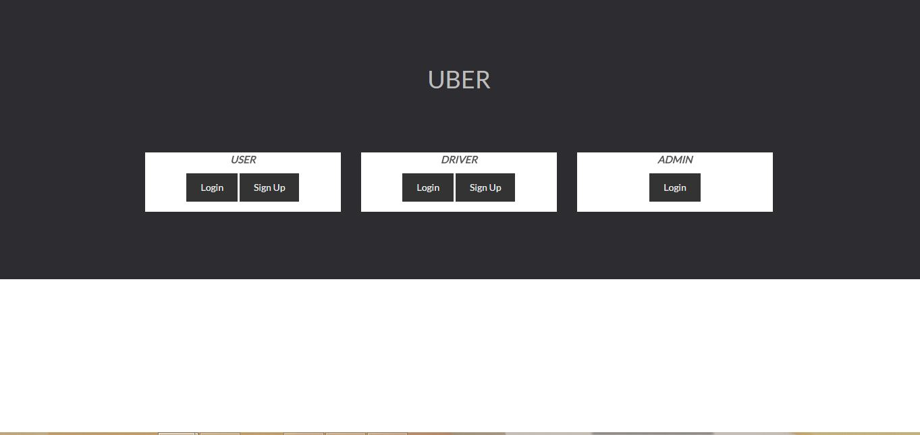

**Login Page**

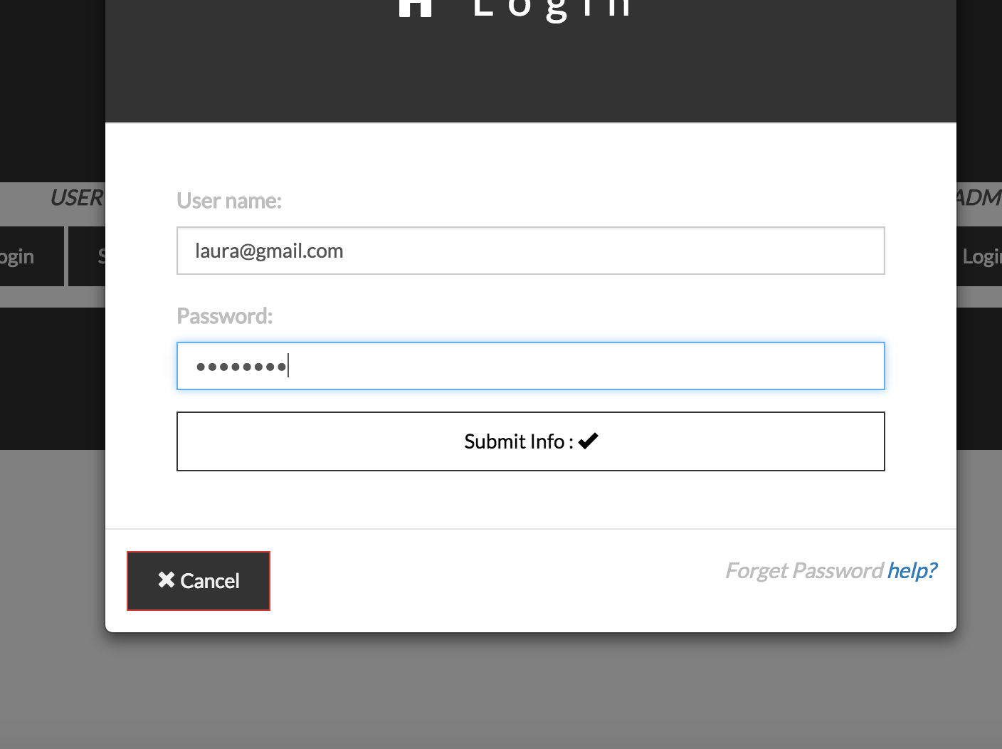

**Signup Page**

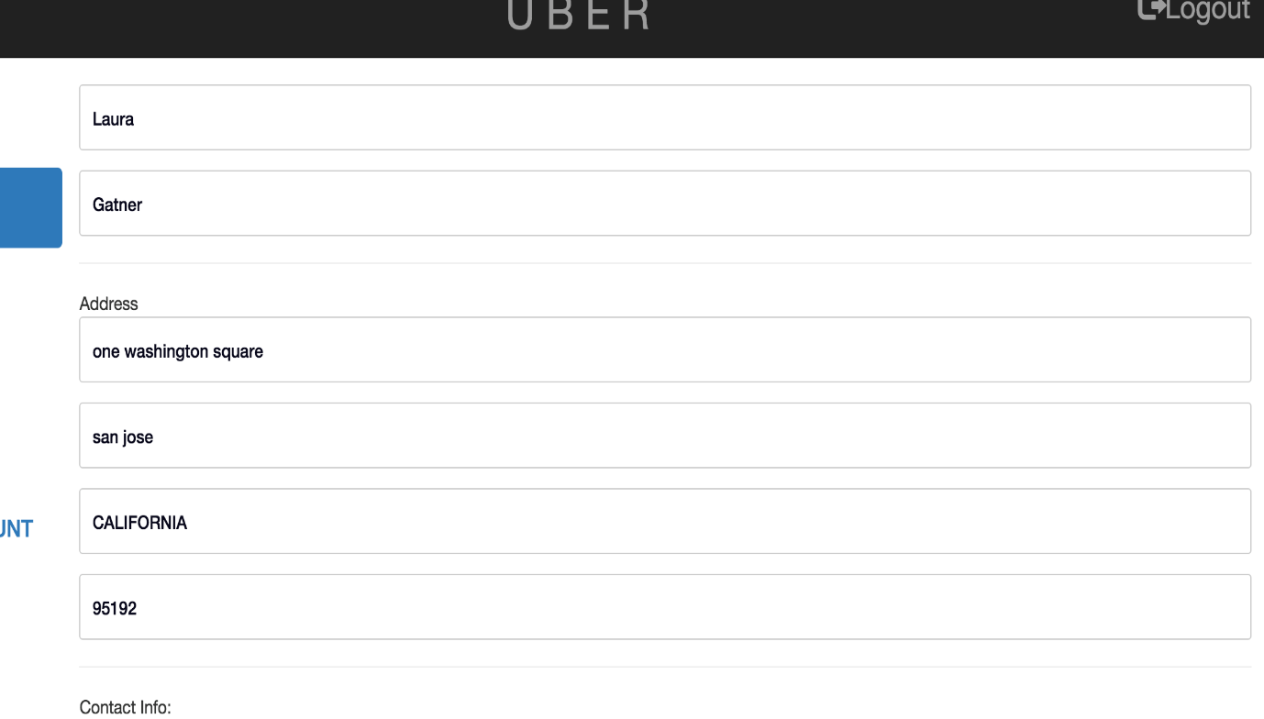

**Invalid Credit card Entered Use Case**

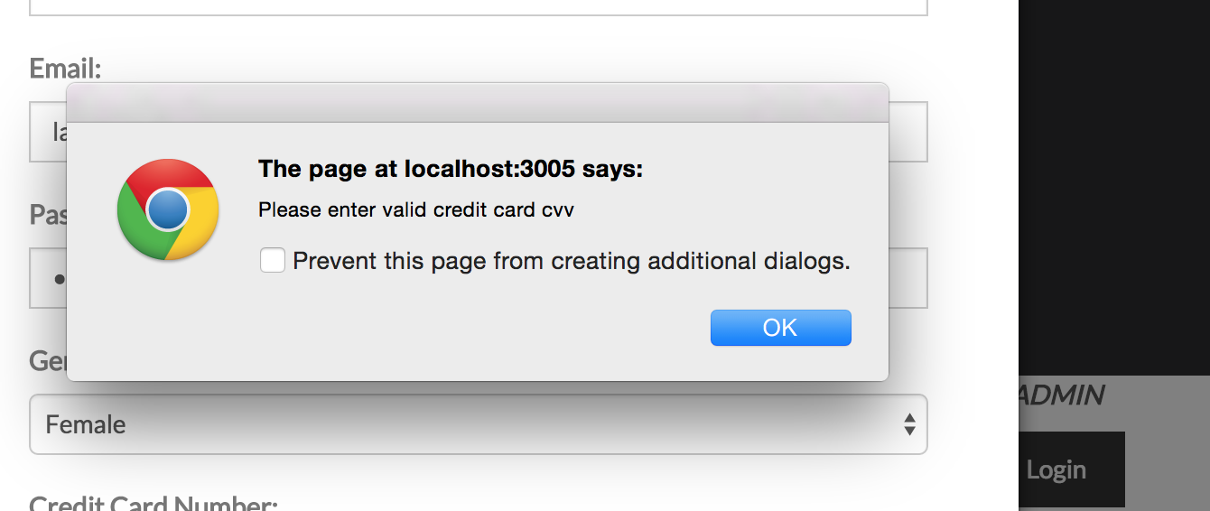

**Successful Signup**

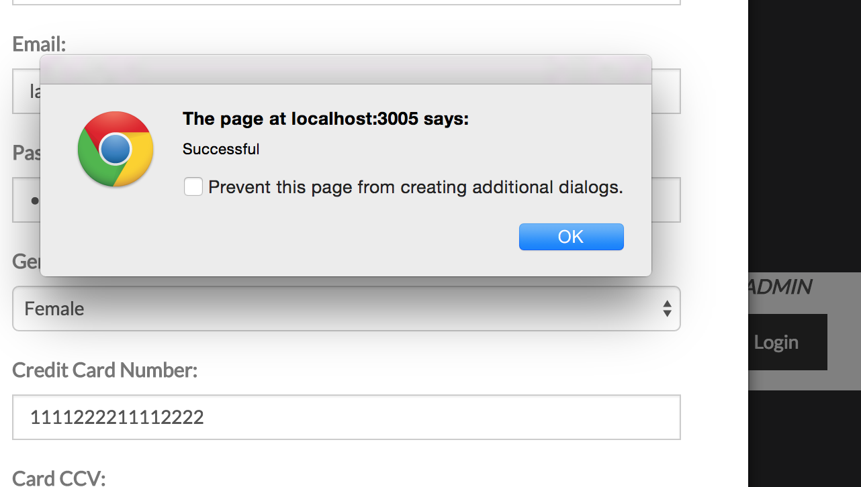

**Email Already in Database**

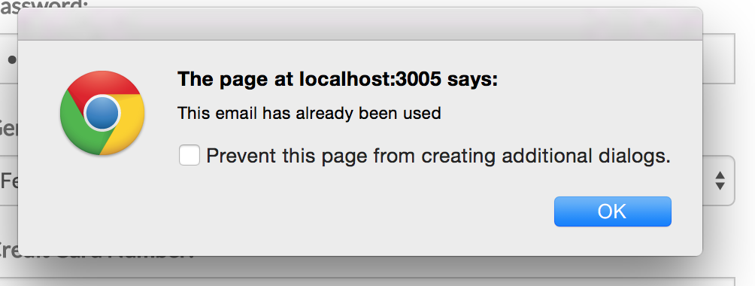

I**ncorrect Zip Code**

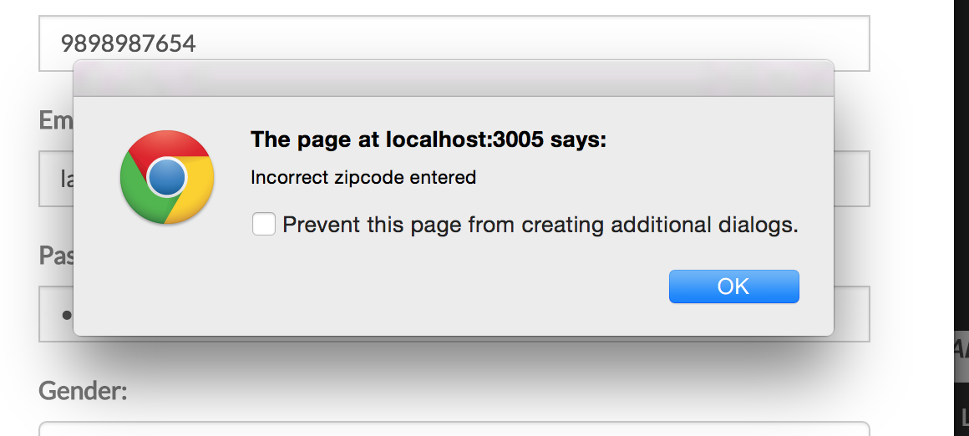

**Sample Credit card and CVV data**

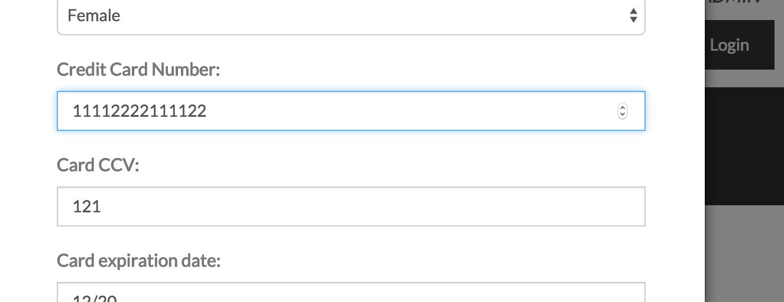

**Error Message for Invalid Data**

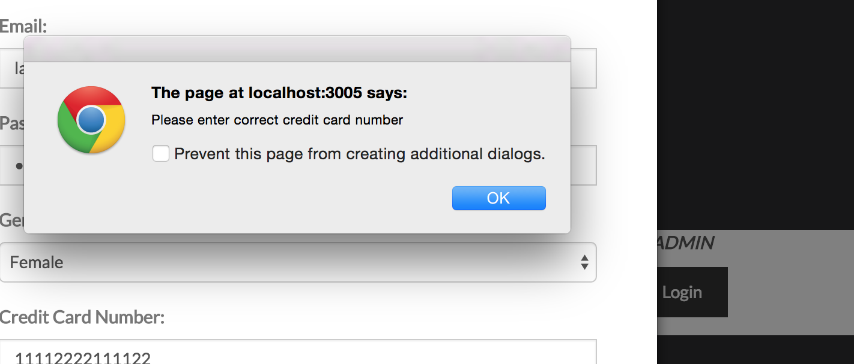

**Application Main Page after Login**

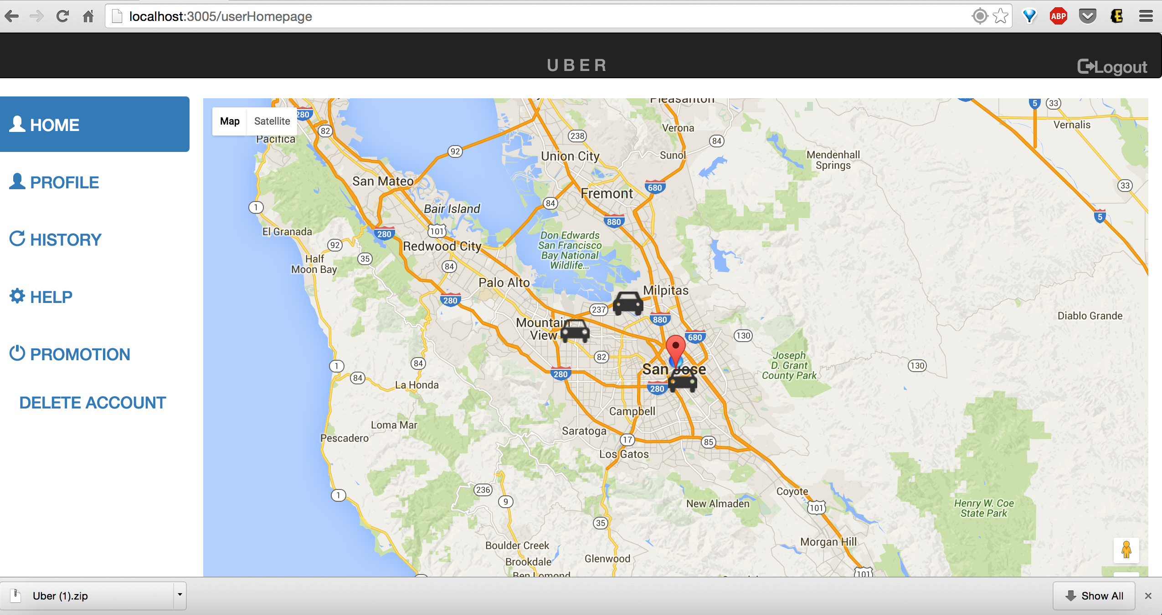

**Request Ride**

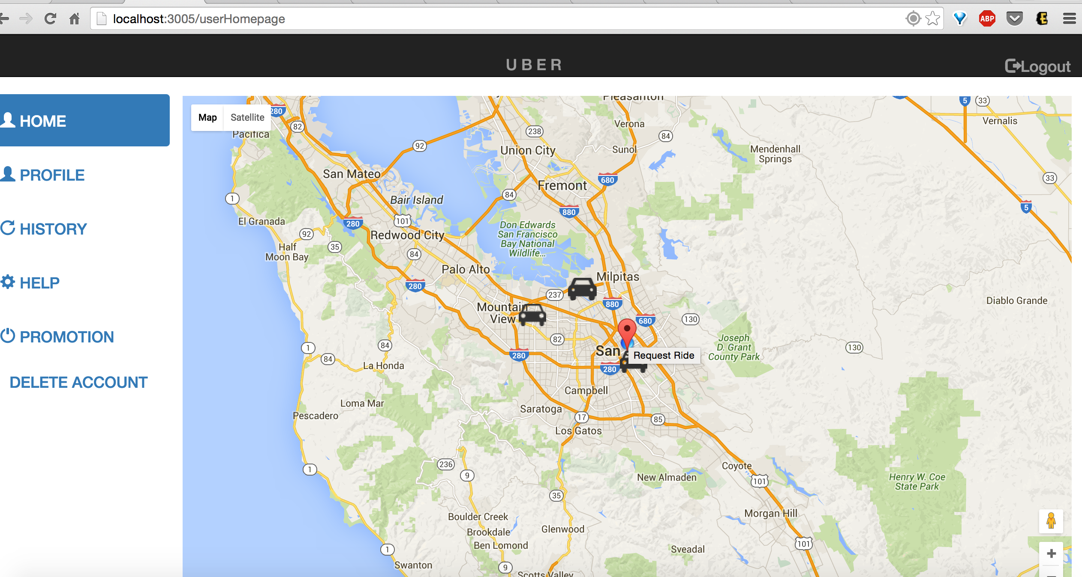

**Request Ride Add destination**

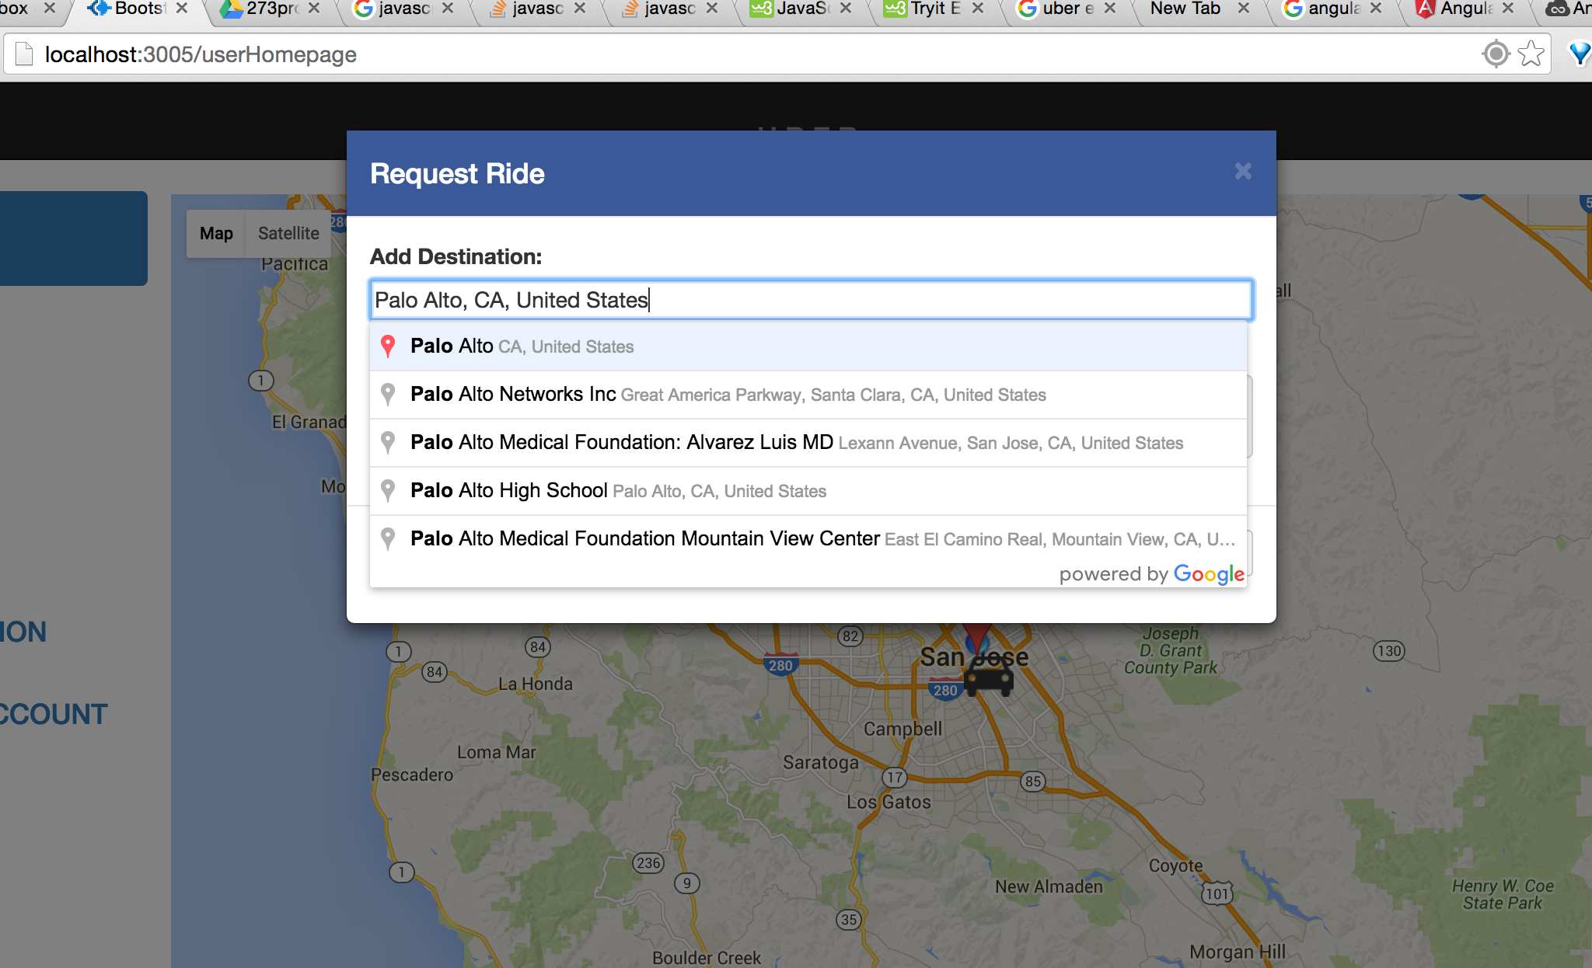

**UBER cabs in the area**

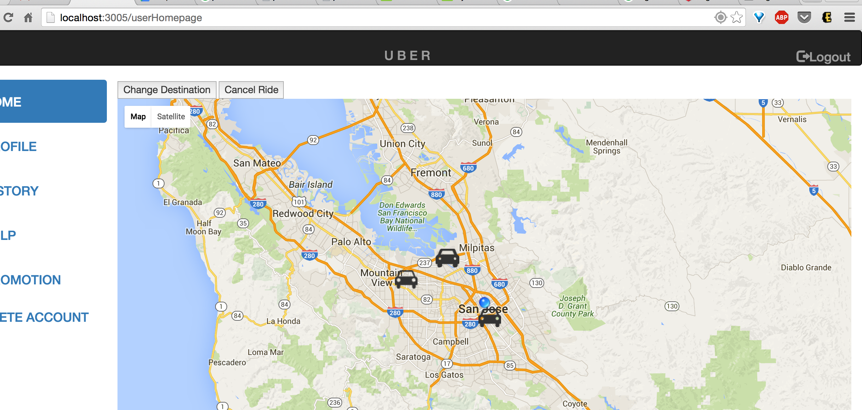

**Driver Info on Map**

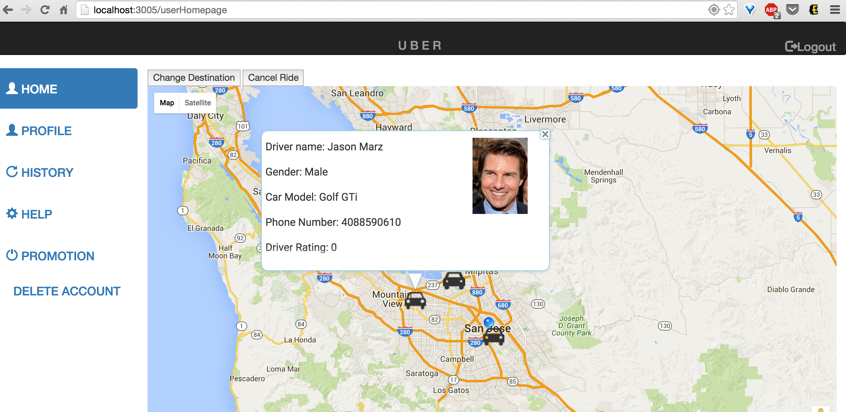

**Youtube Video of Driver**

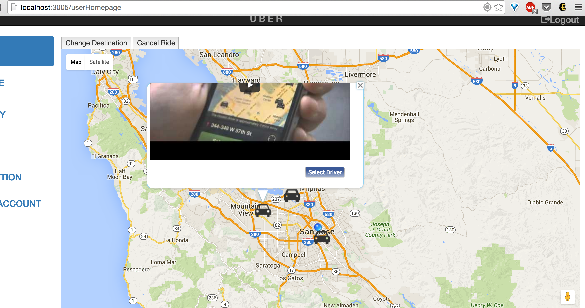

**Ride Requested and Driver on the Way**

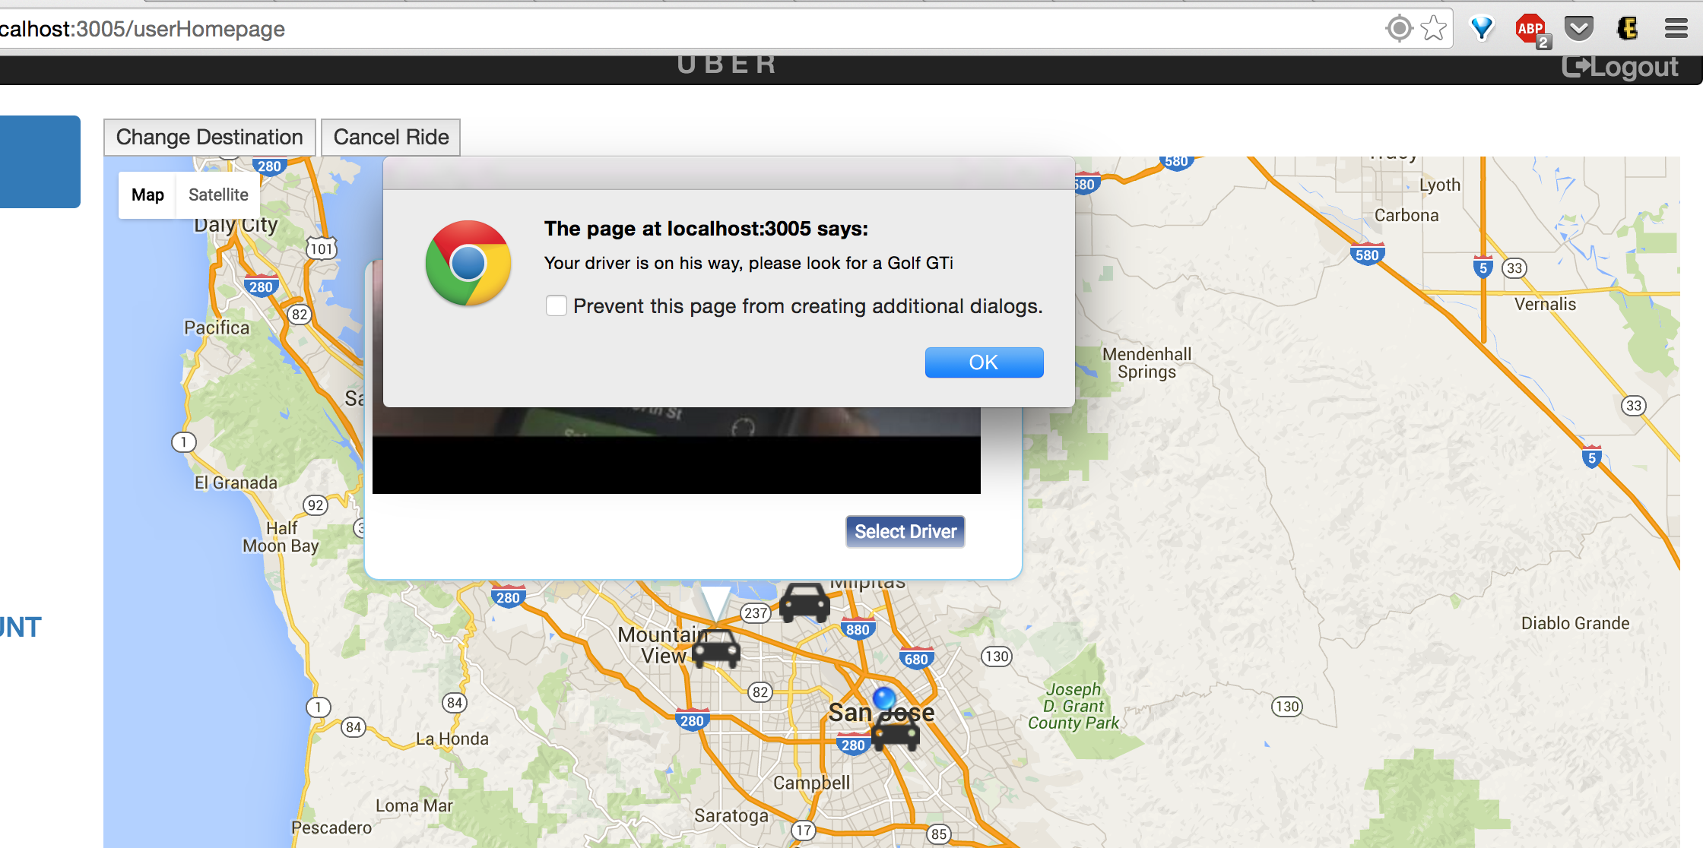

**The driver status**

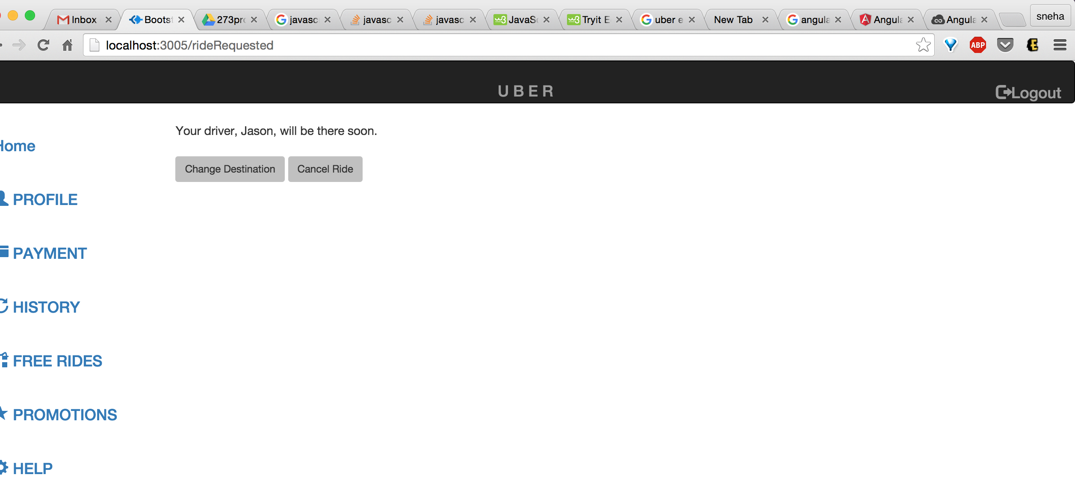

**Request Ride**

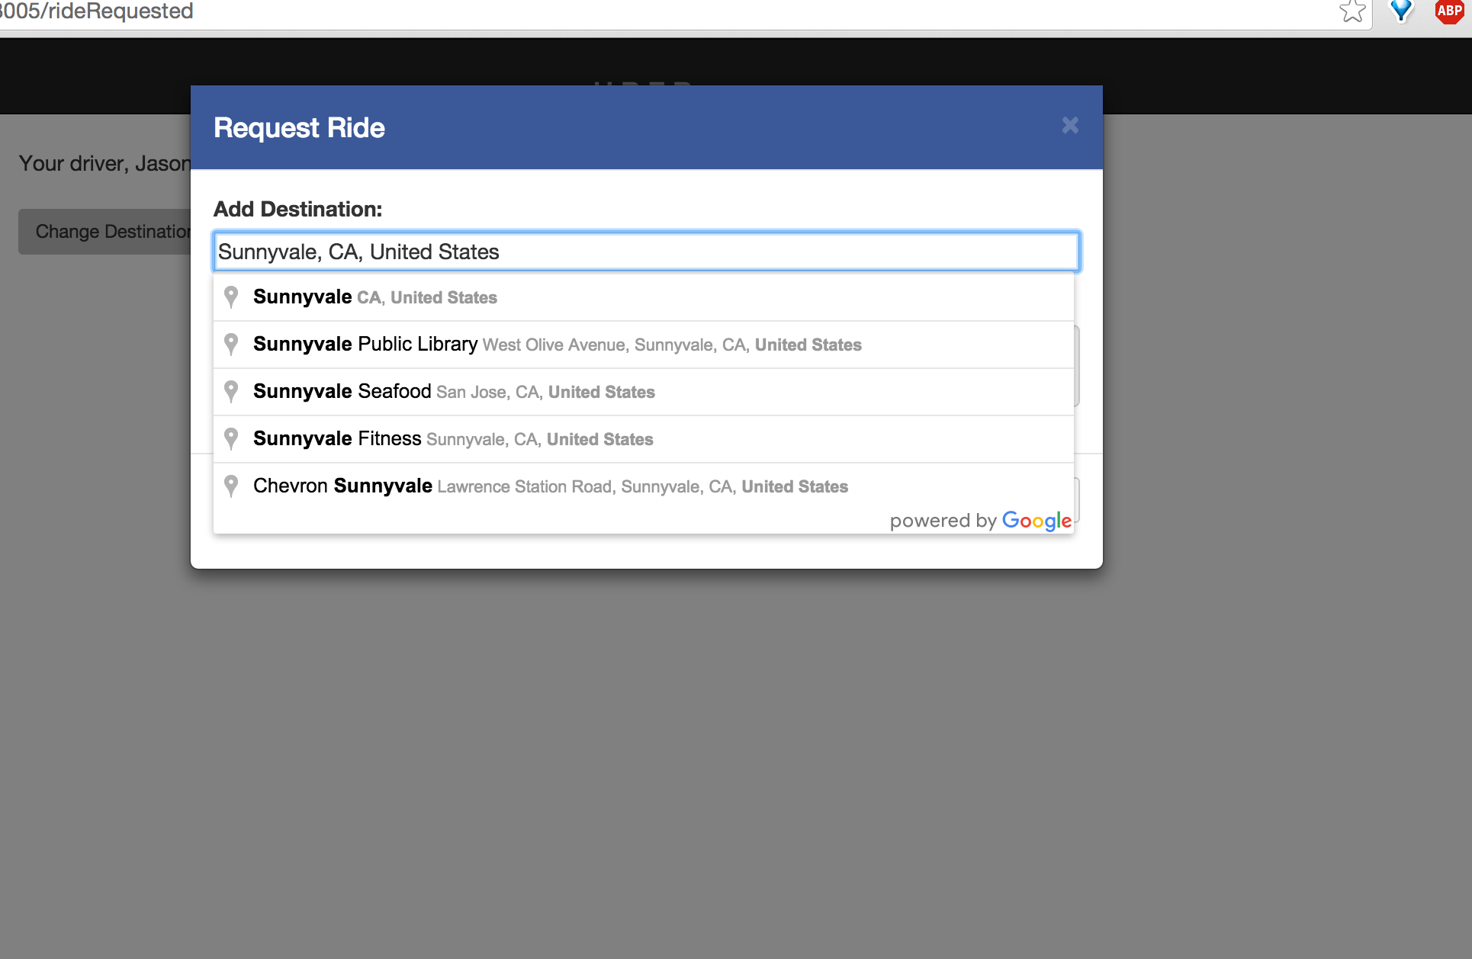

**Update Profile Module**

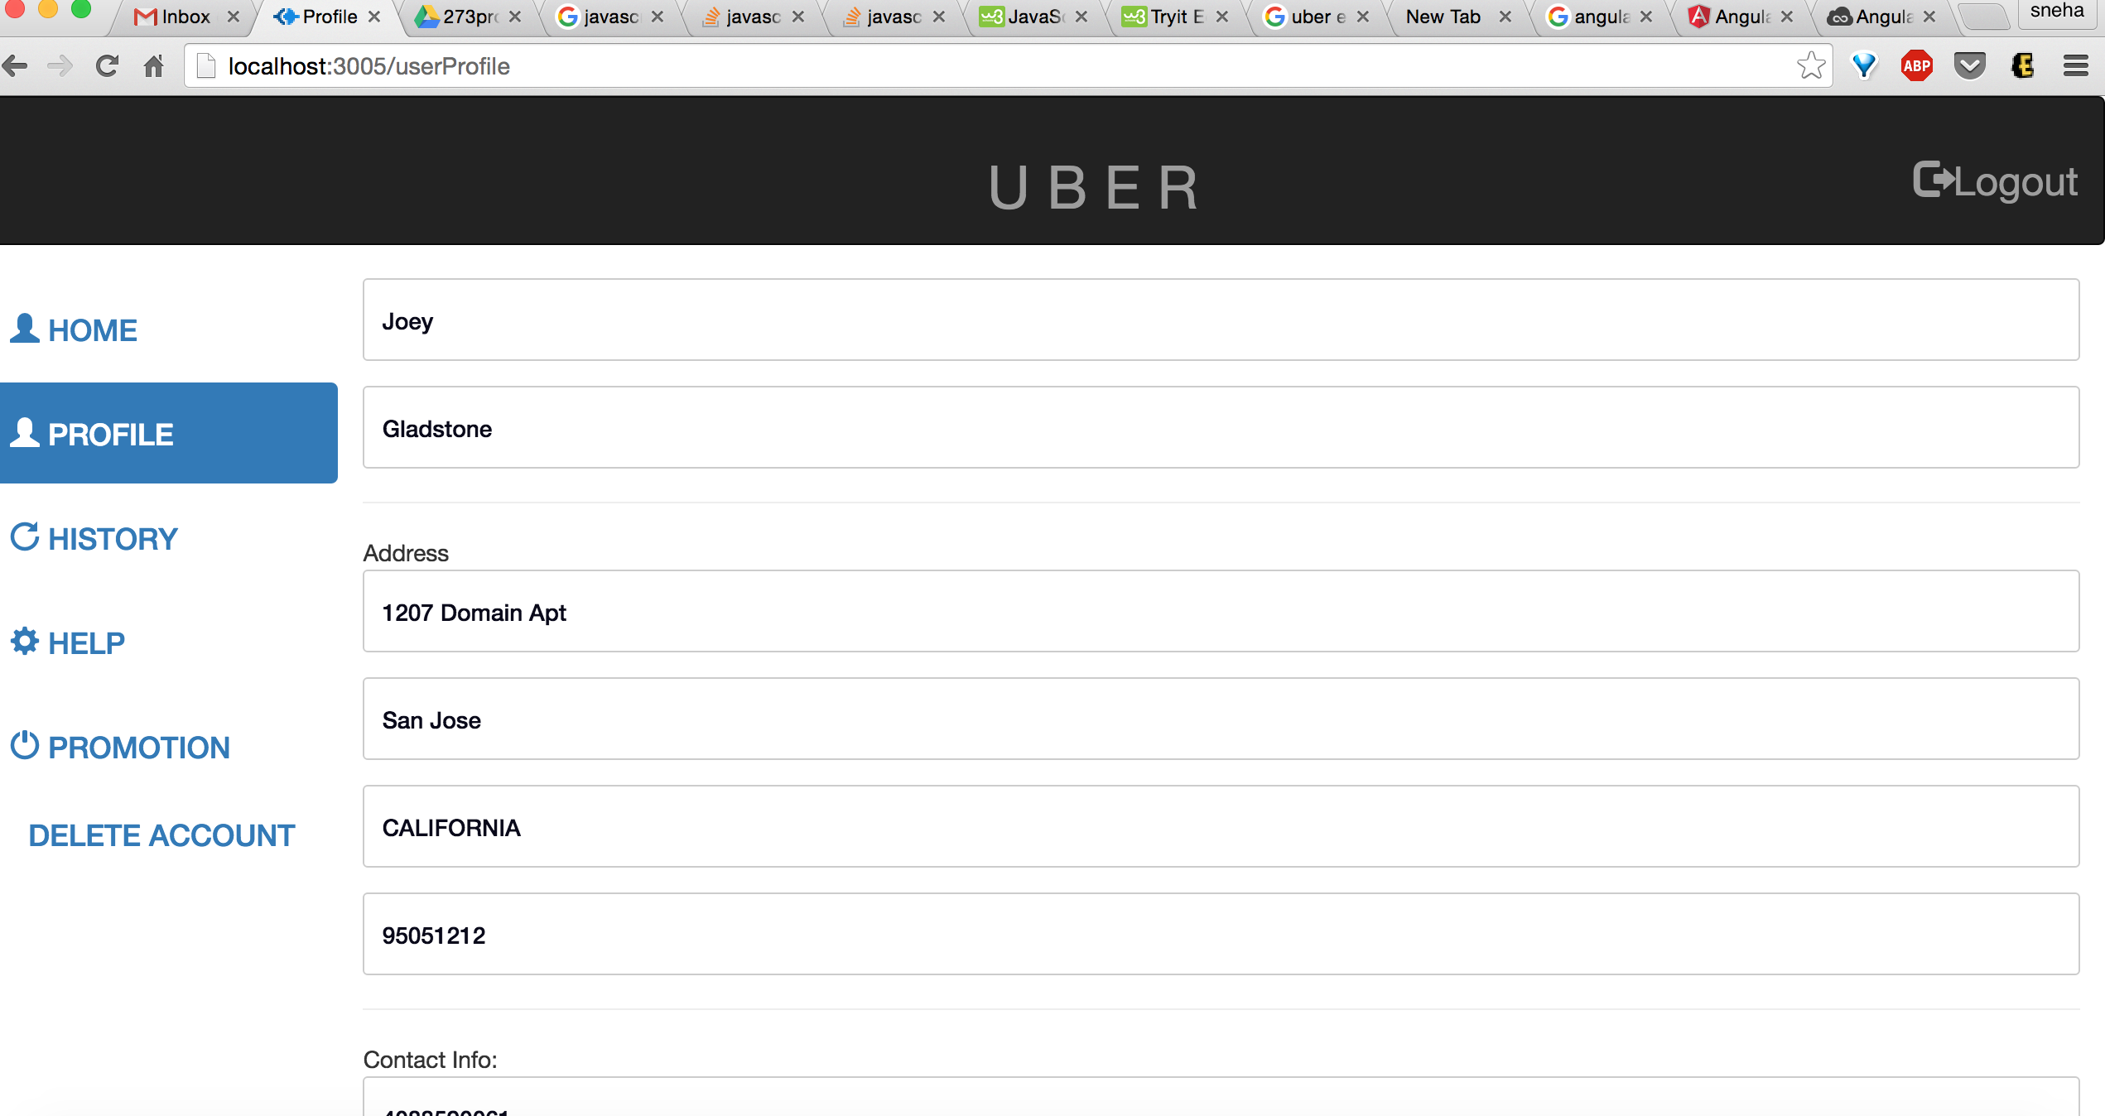

**History Page**

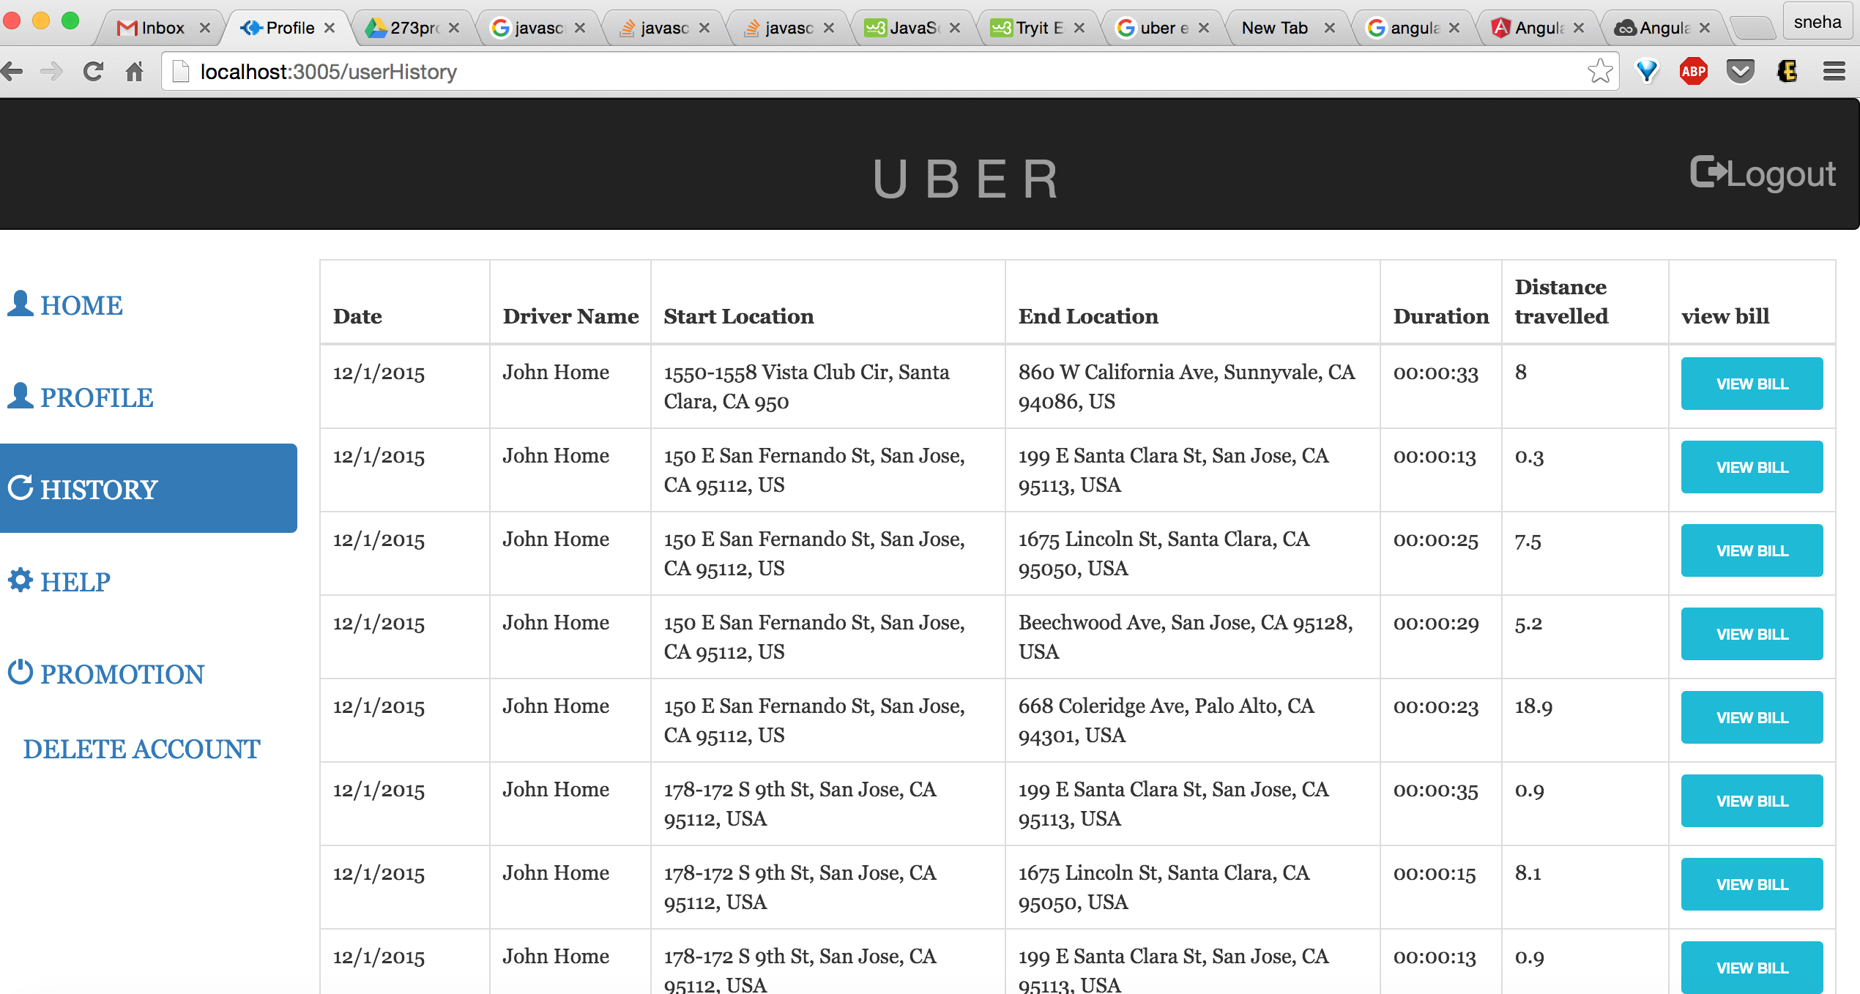

**Generated Bill**

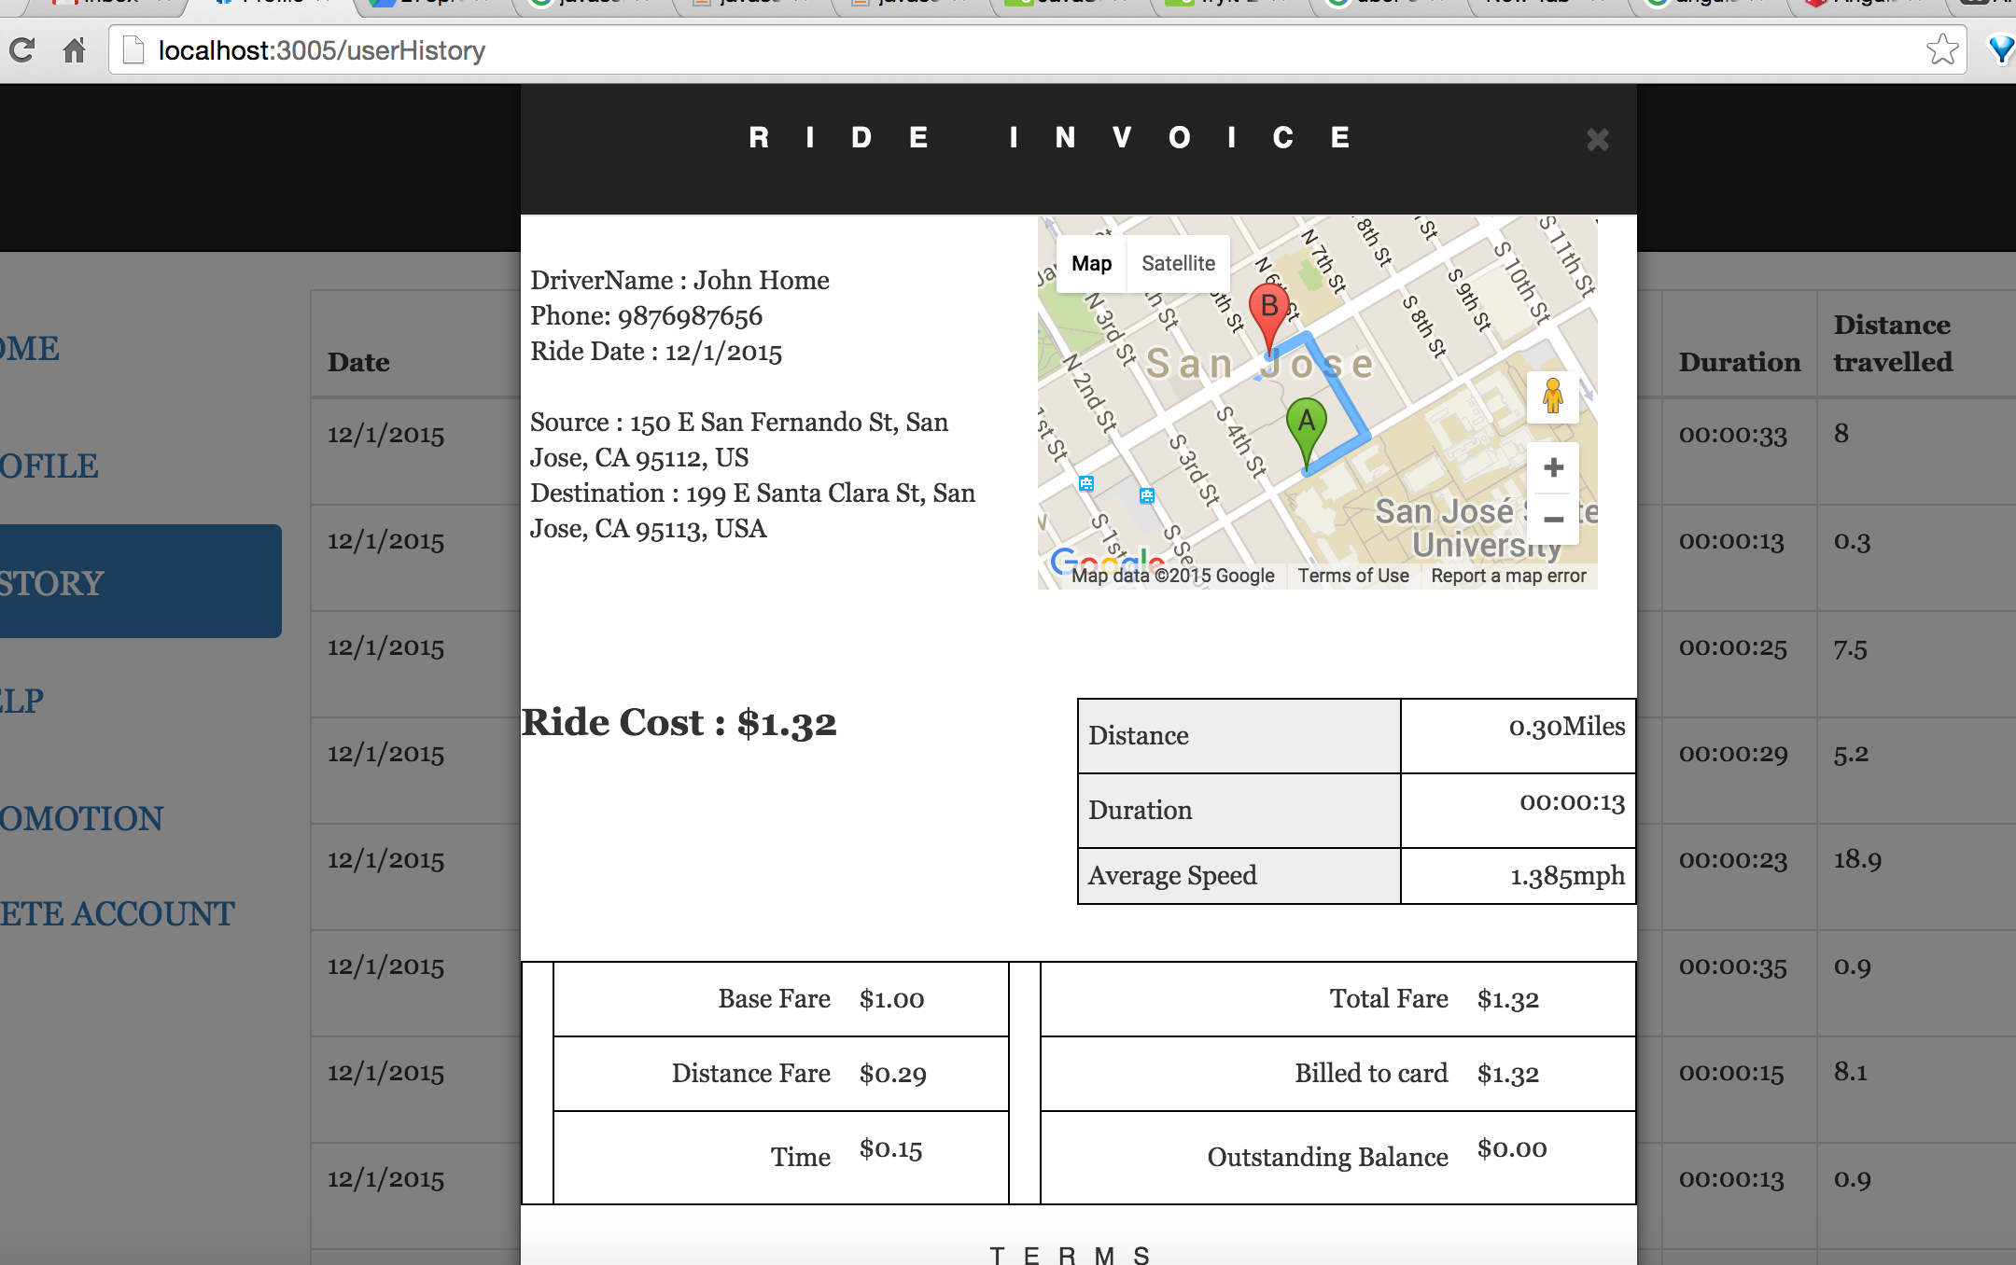

**Profile information Page**

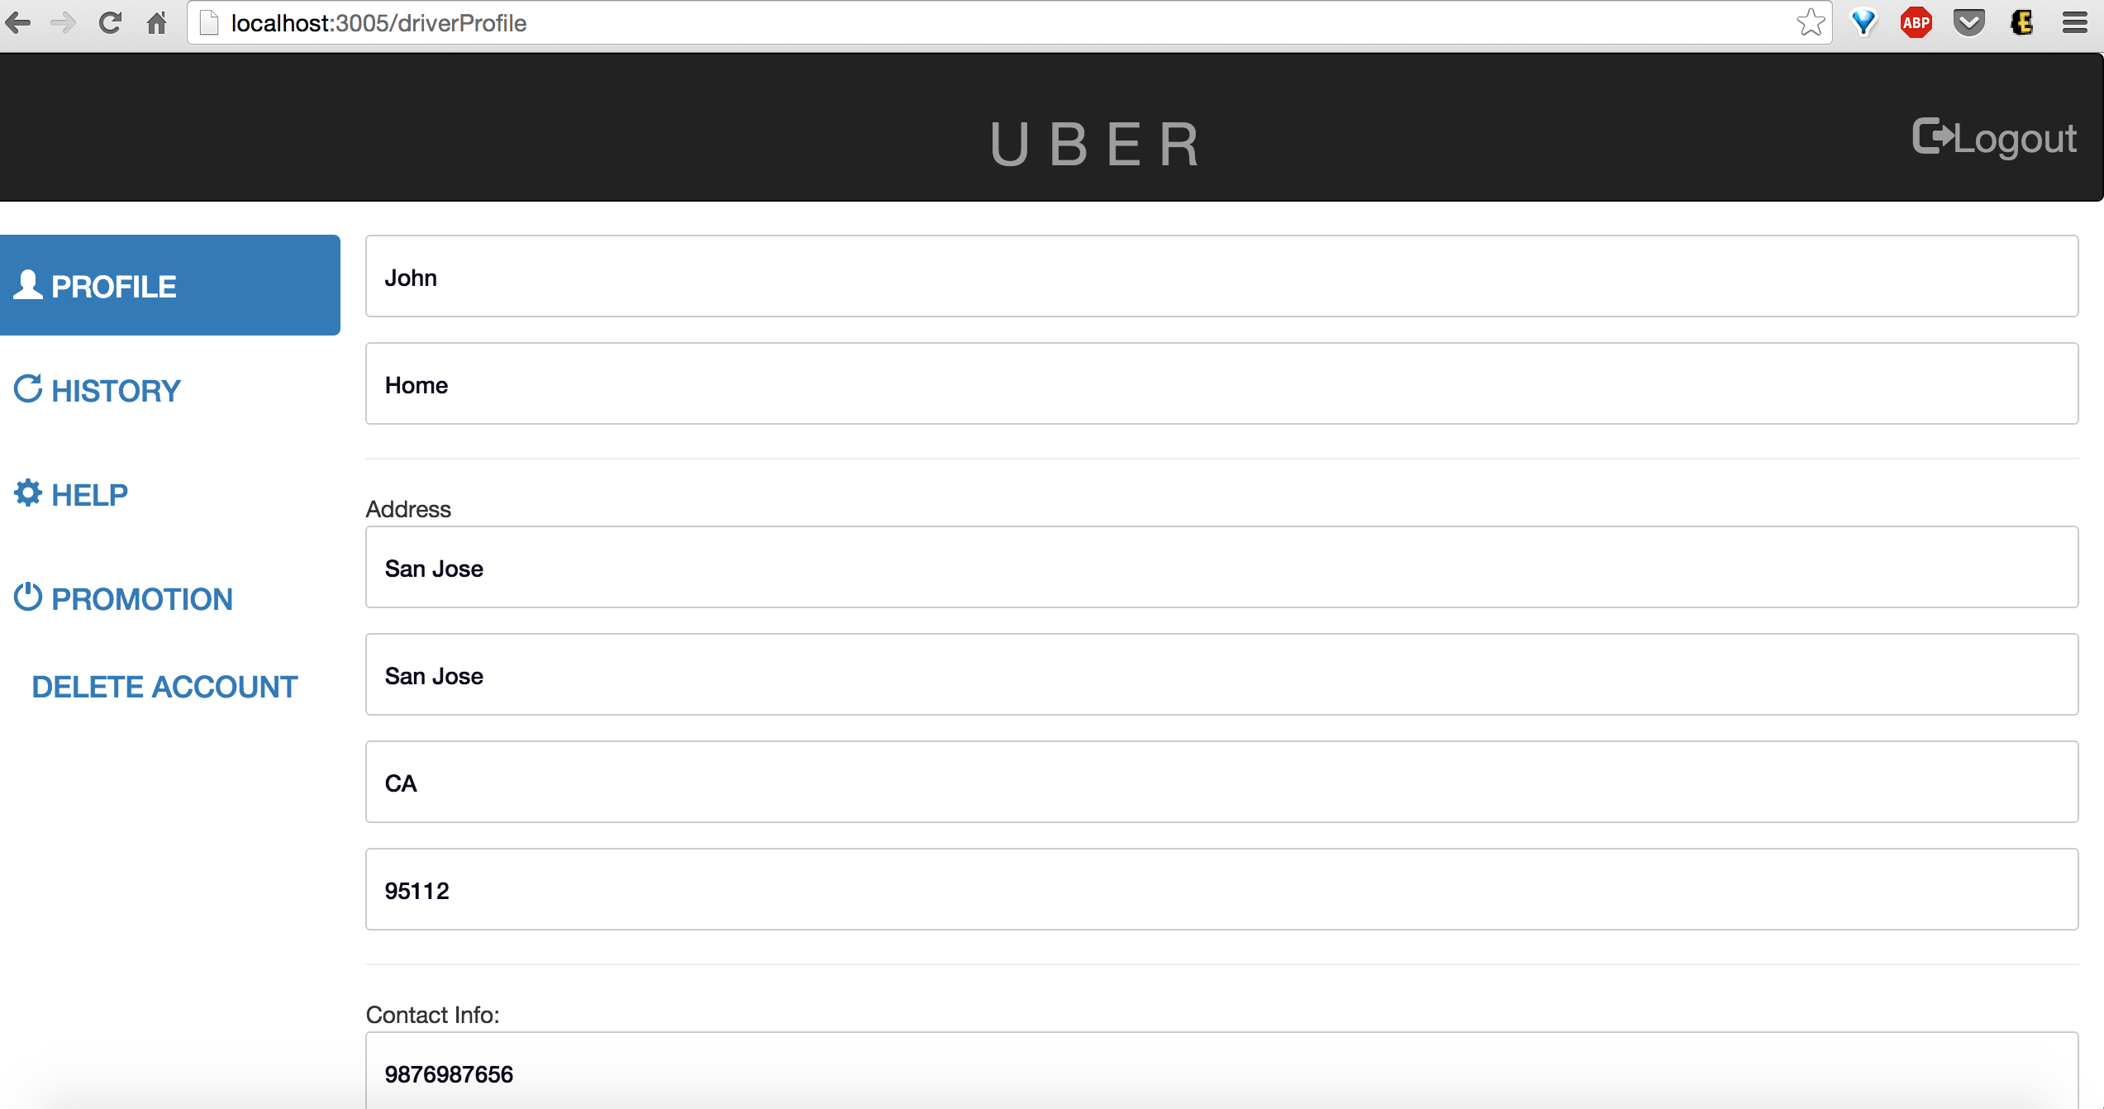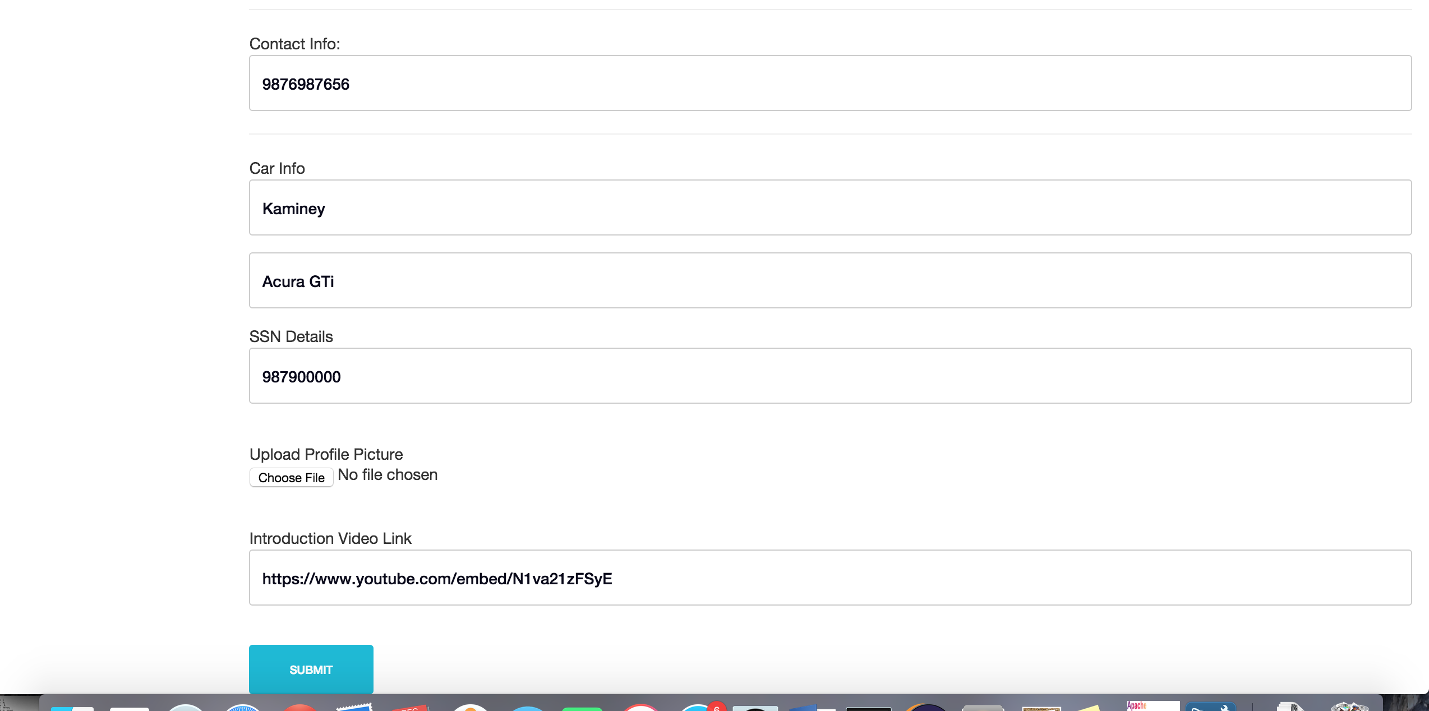

**Generate Bill**

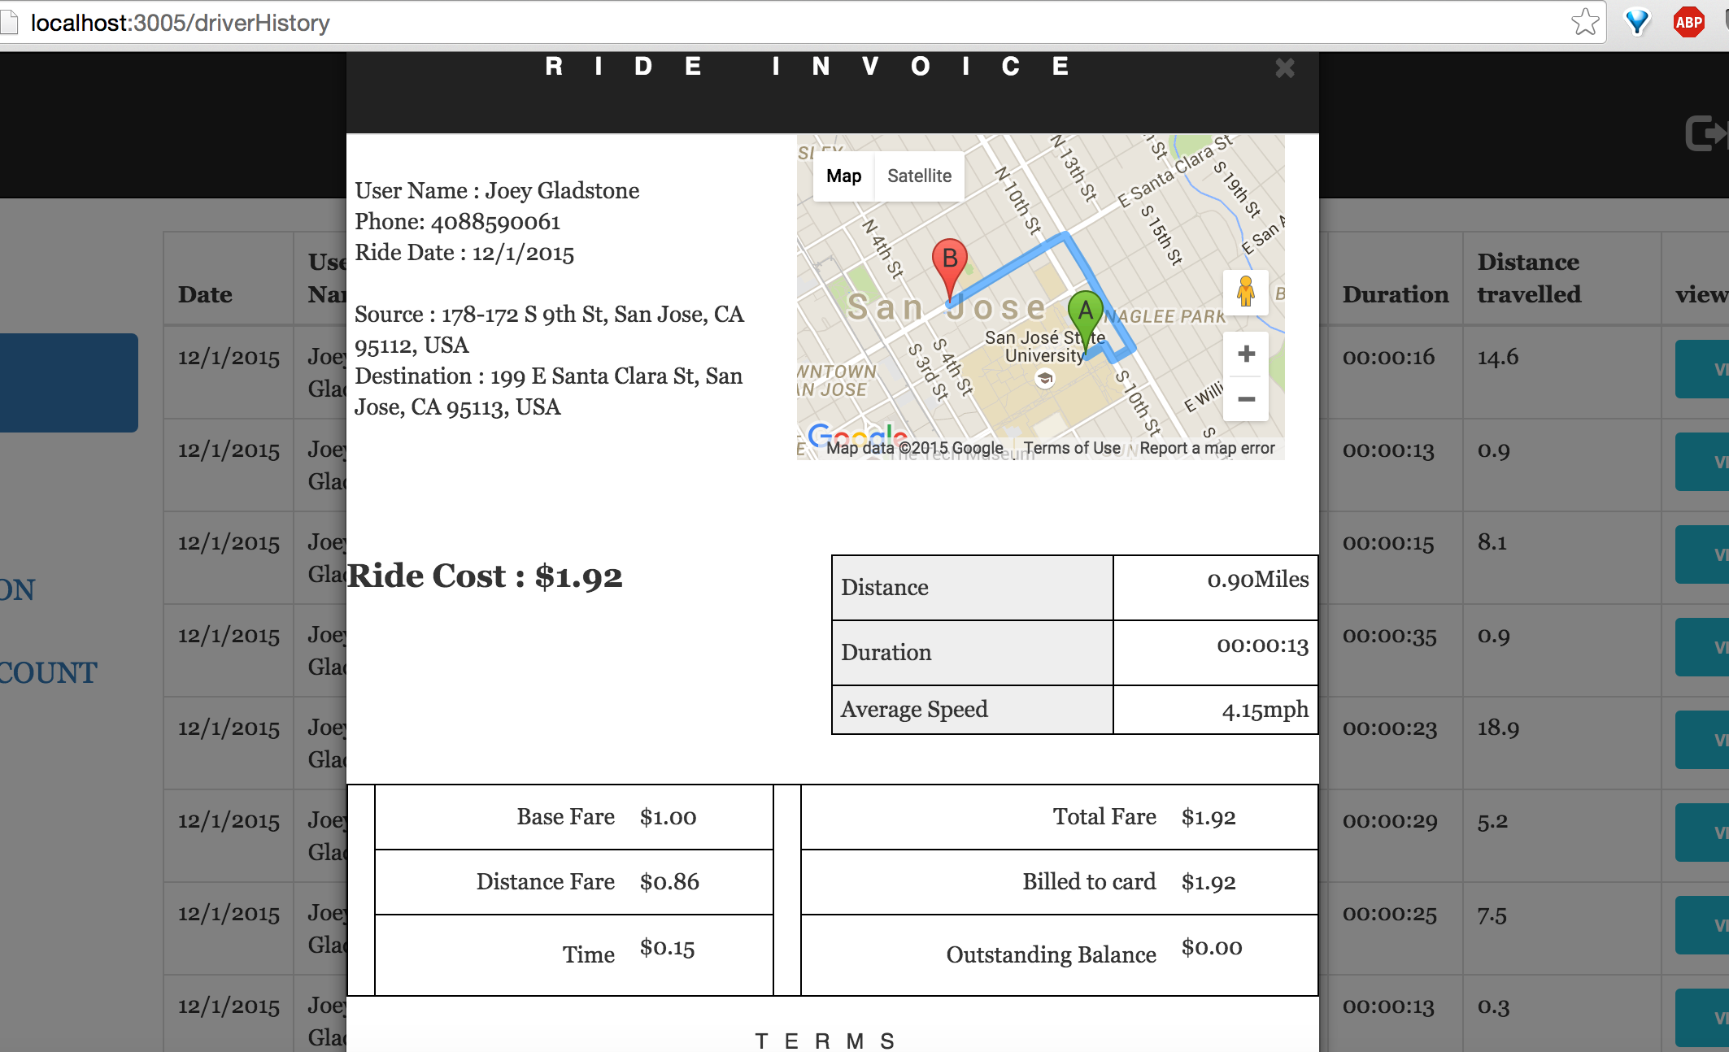

**Upload Profile Picture**

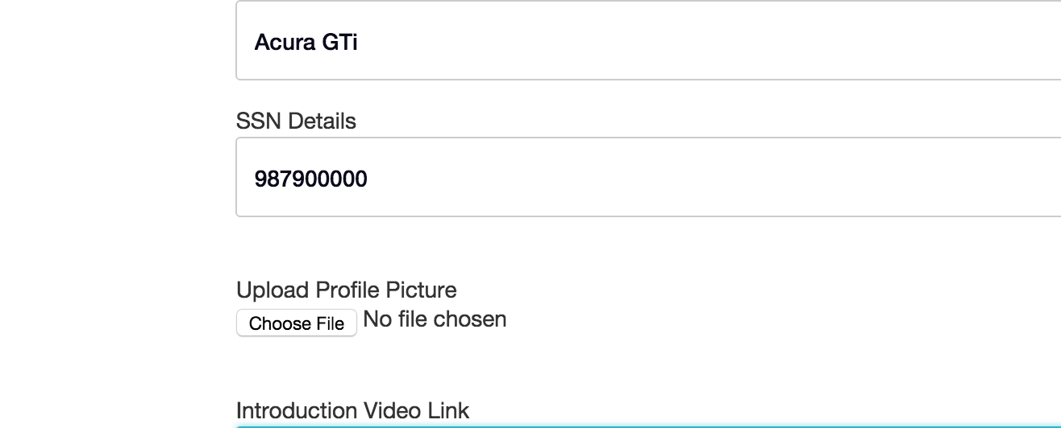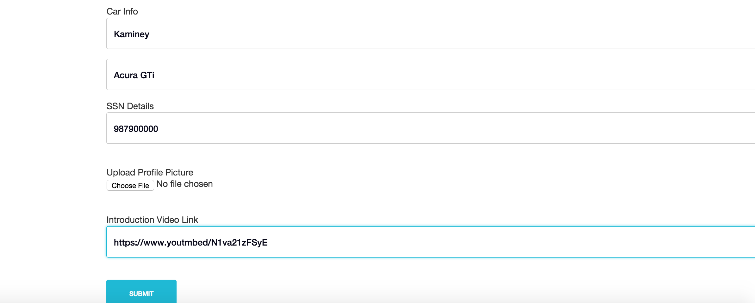

**Invalid Youtube Link**

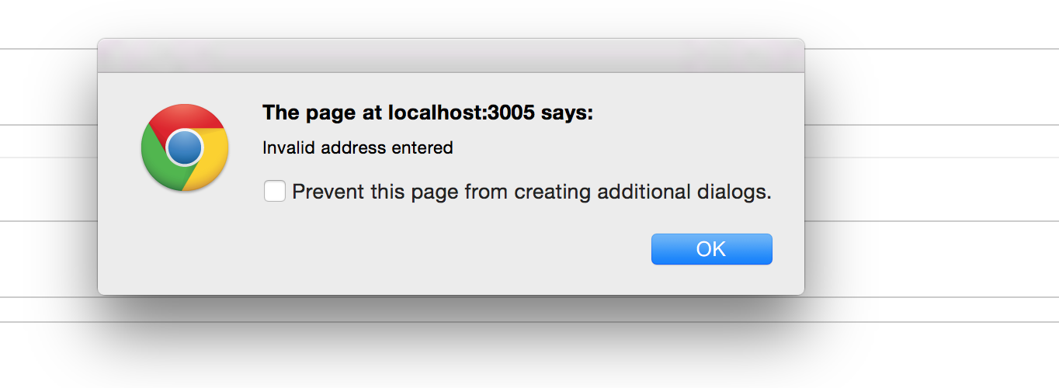

**State does not match with Address Error Message**

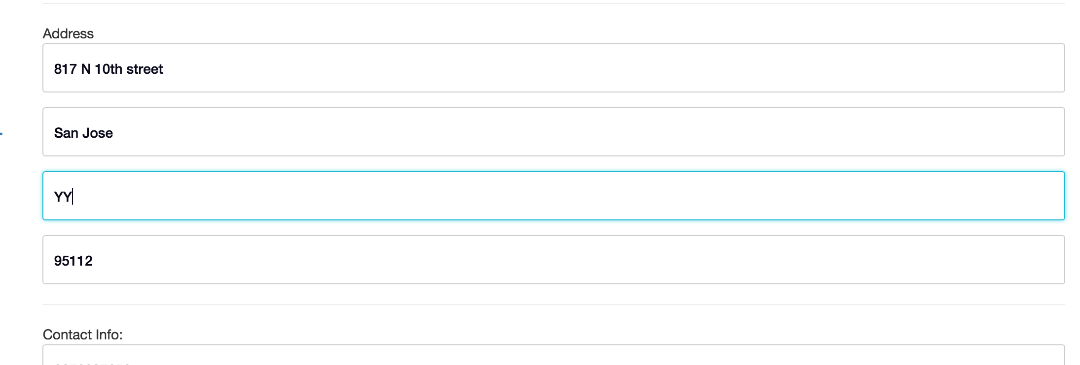

**Zipcode does not match with address Error**

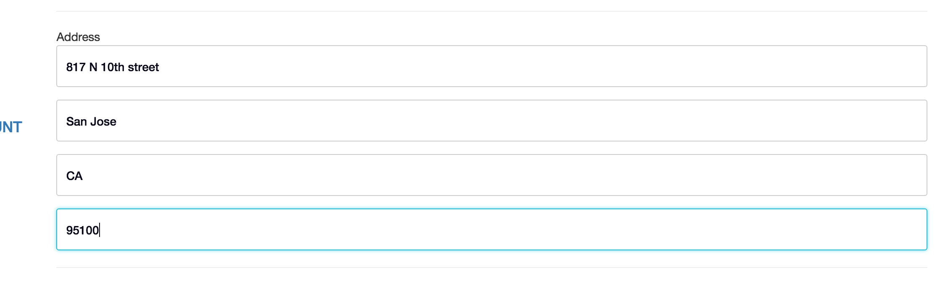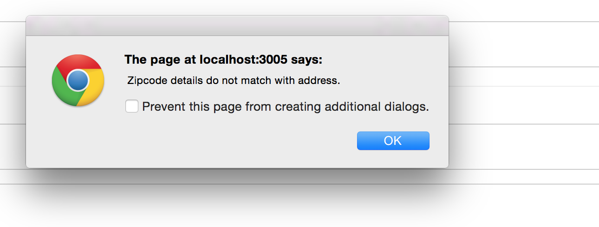

**Driver Ride Requested**

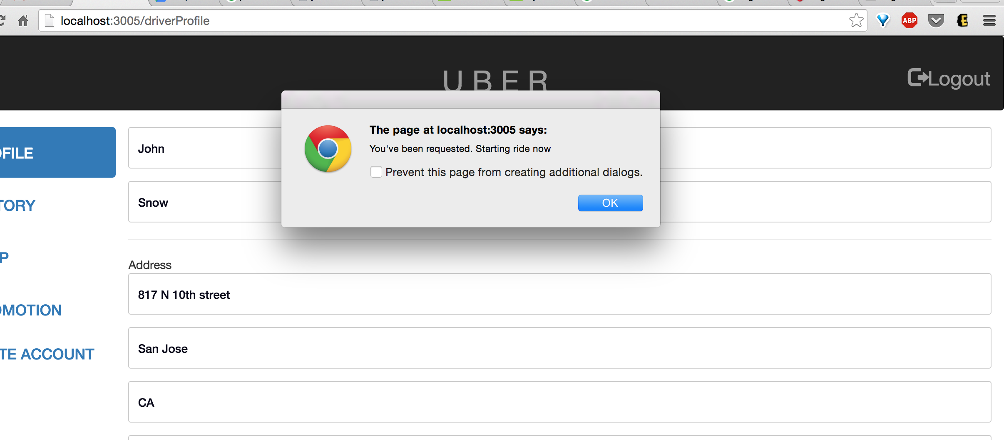

**(Driver)Ride has been started**

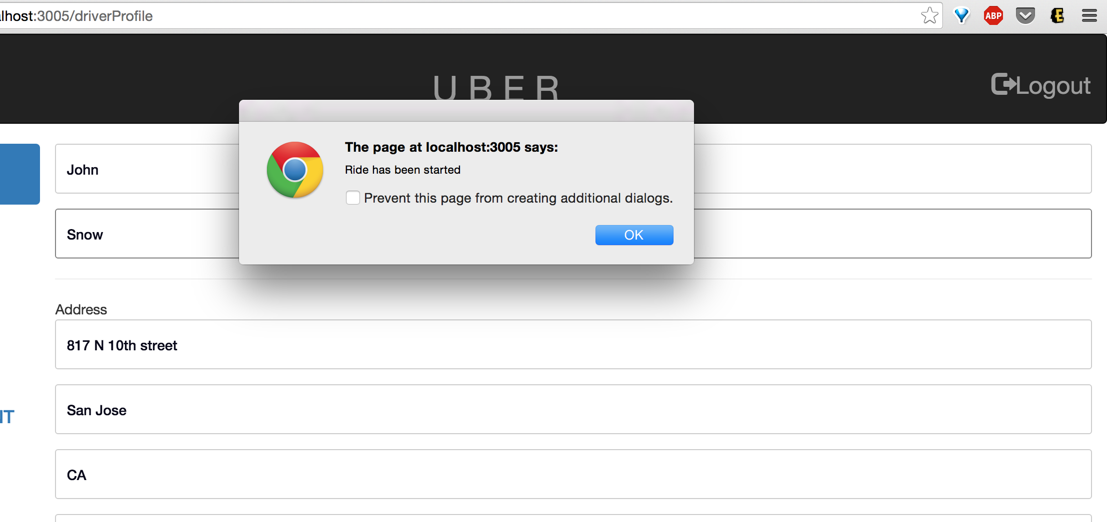

**(Driver)During Ride**

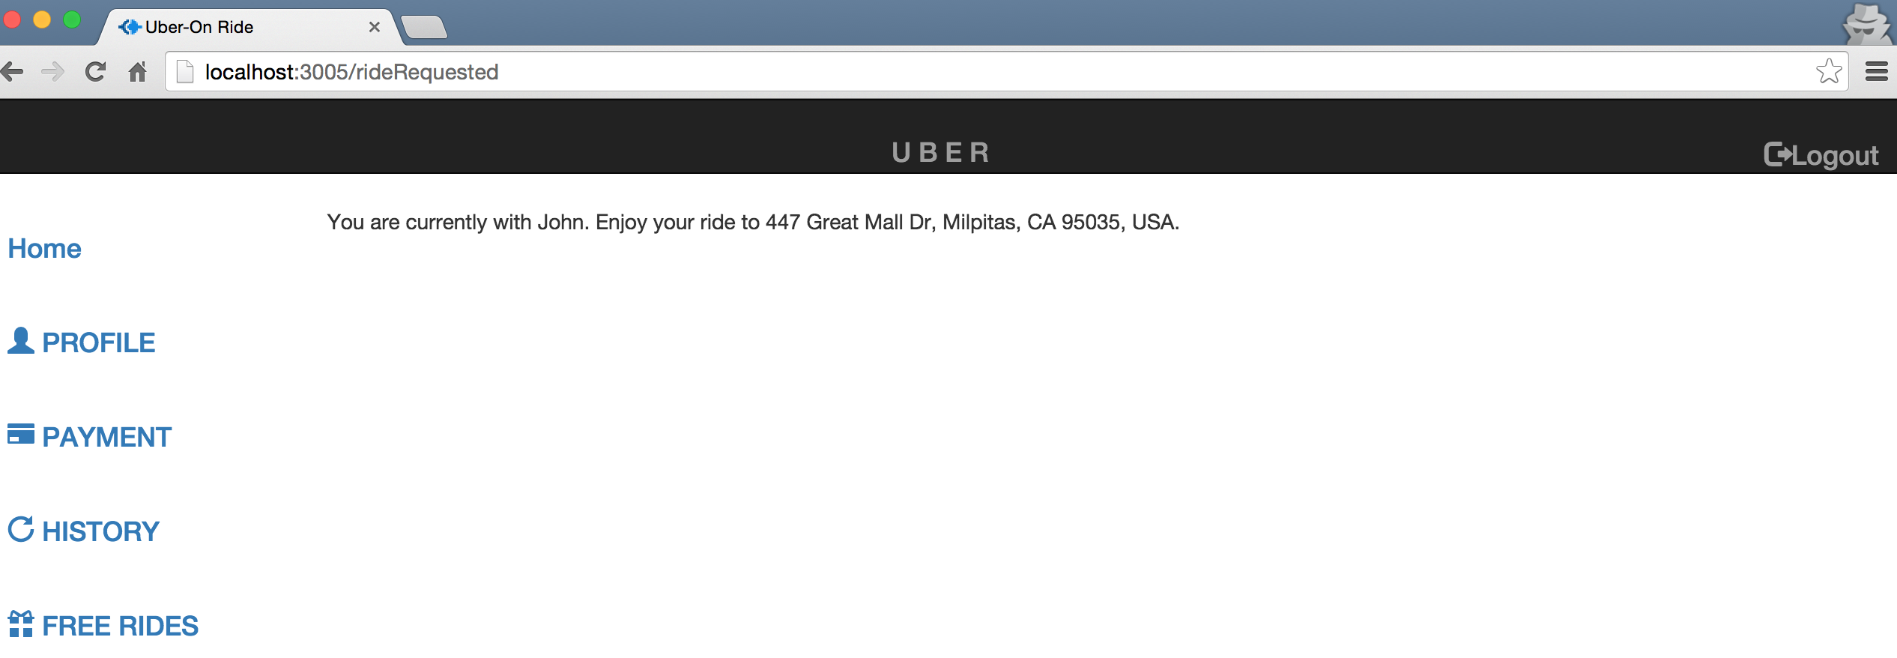

**End Ride**

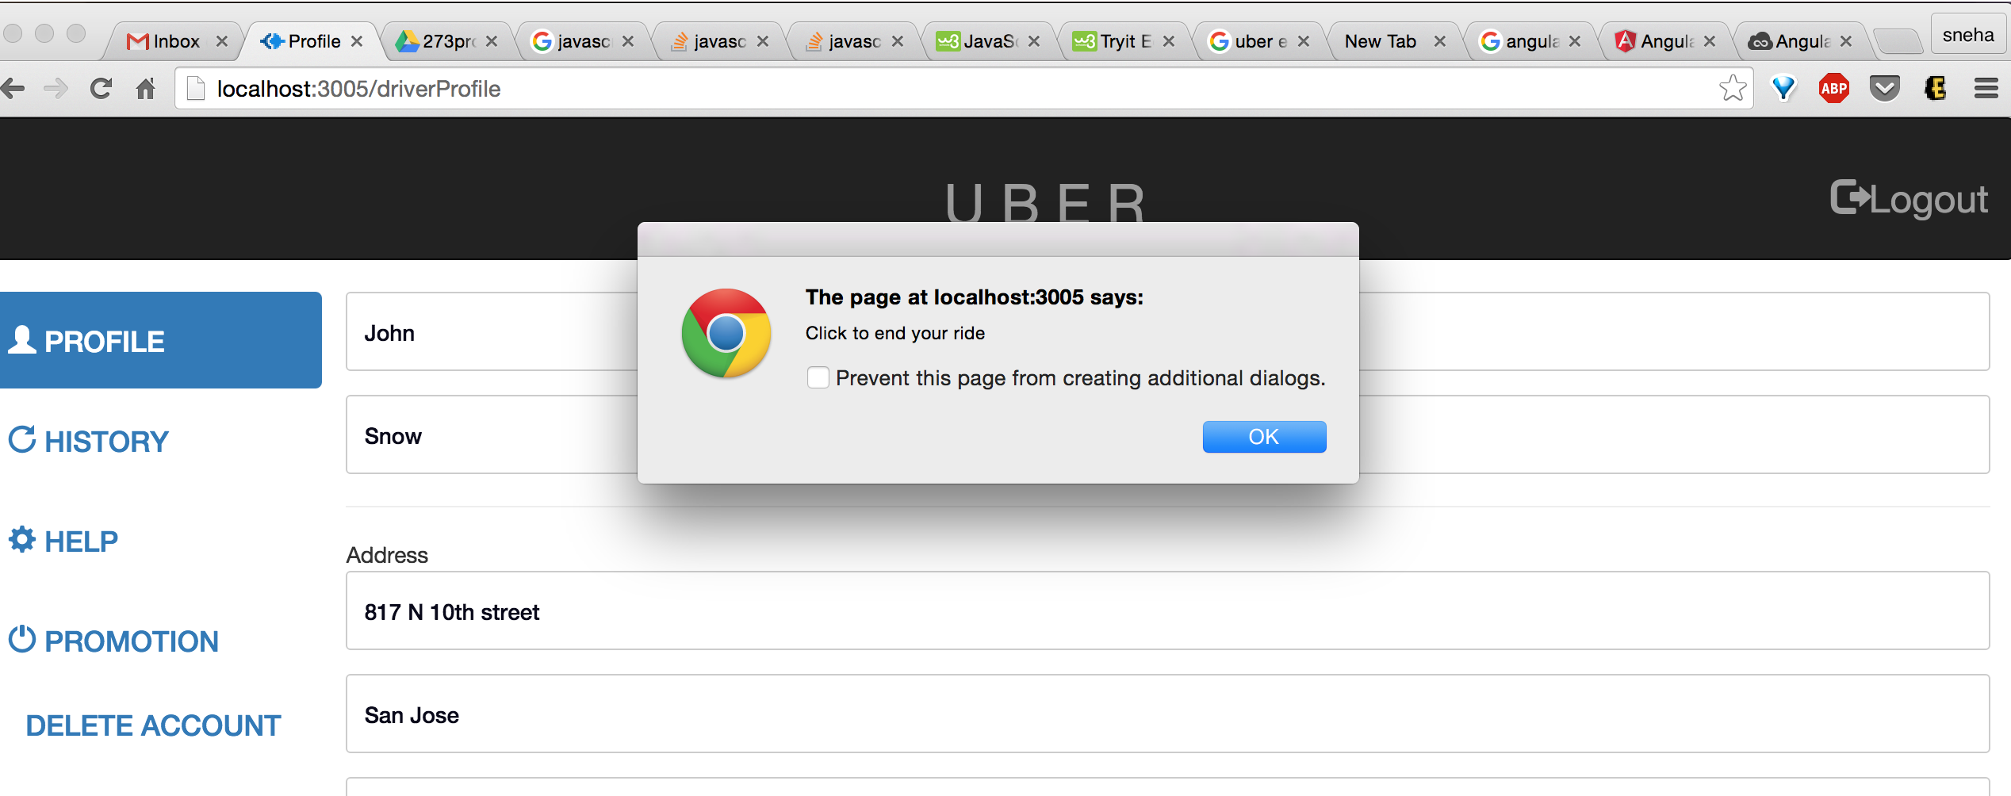

**Ride has been Ended**

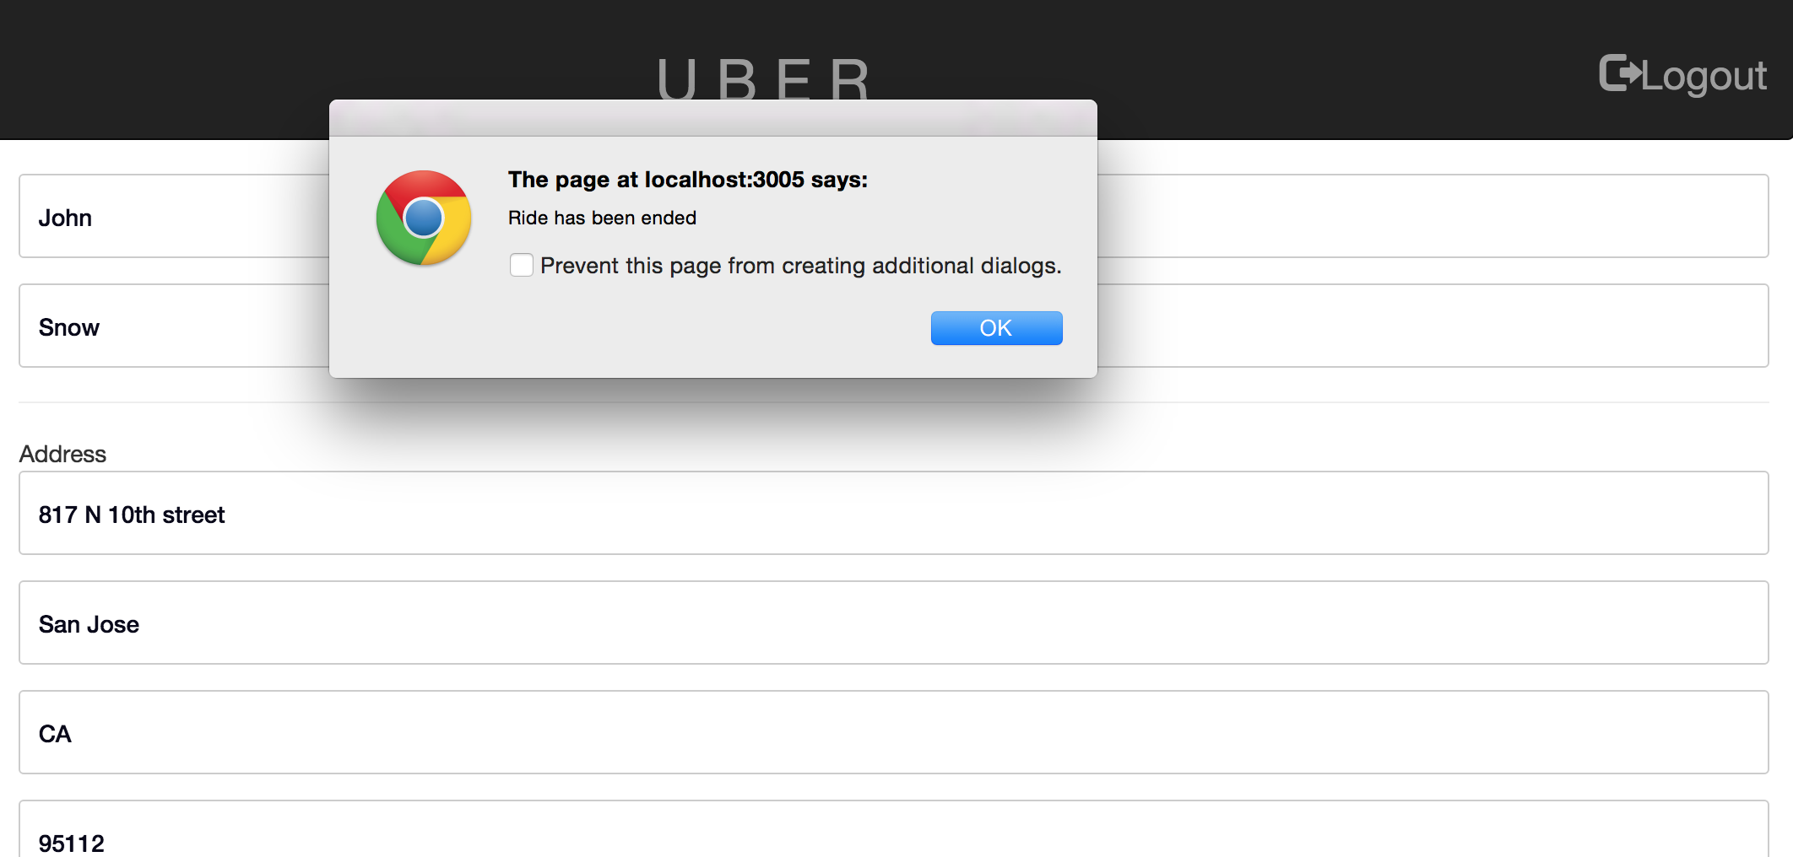

**Driver Rates User**

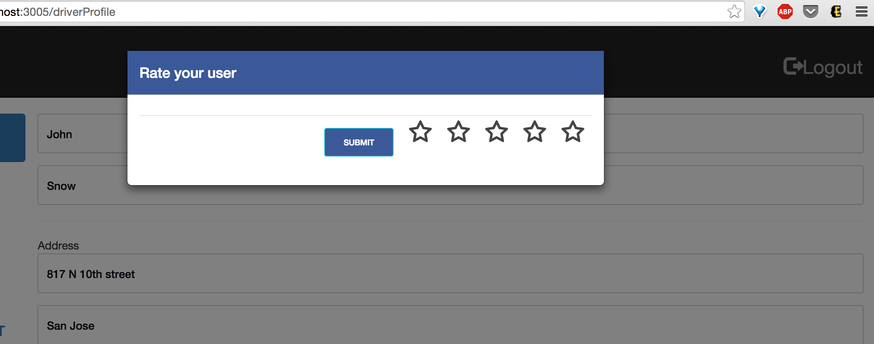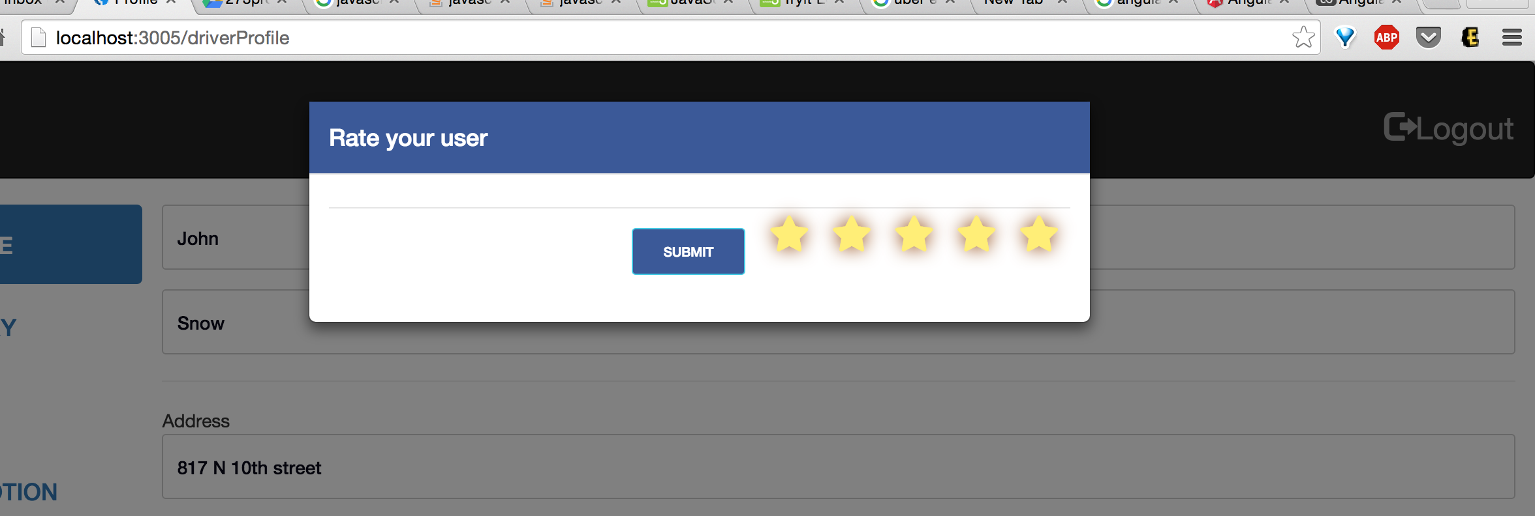

**User rates Driver**

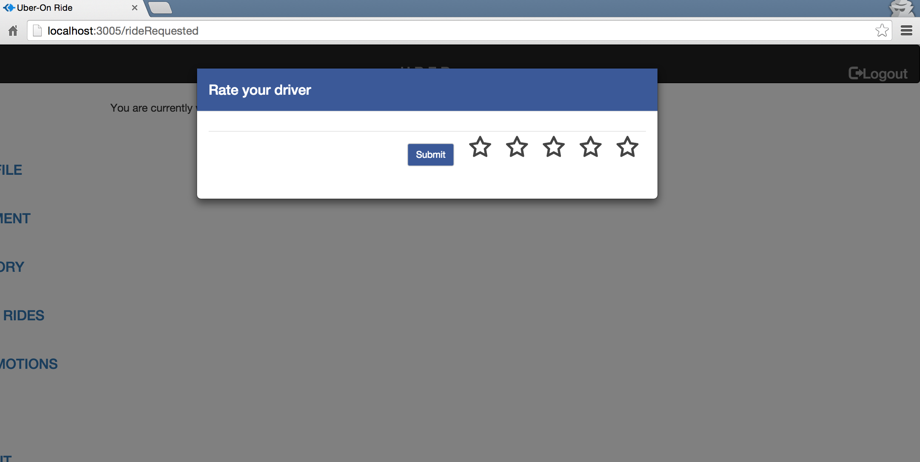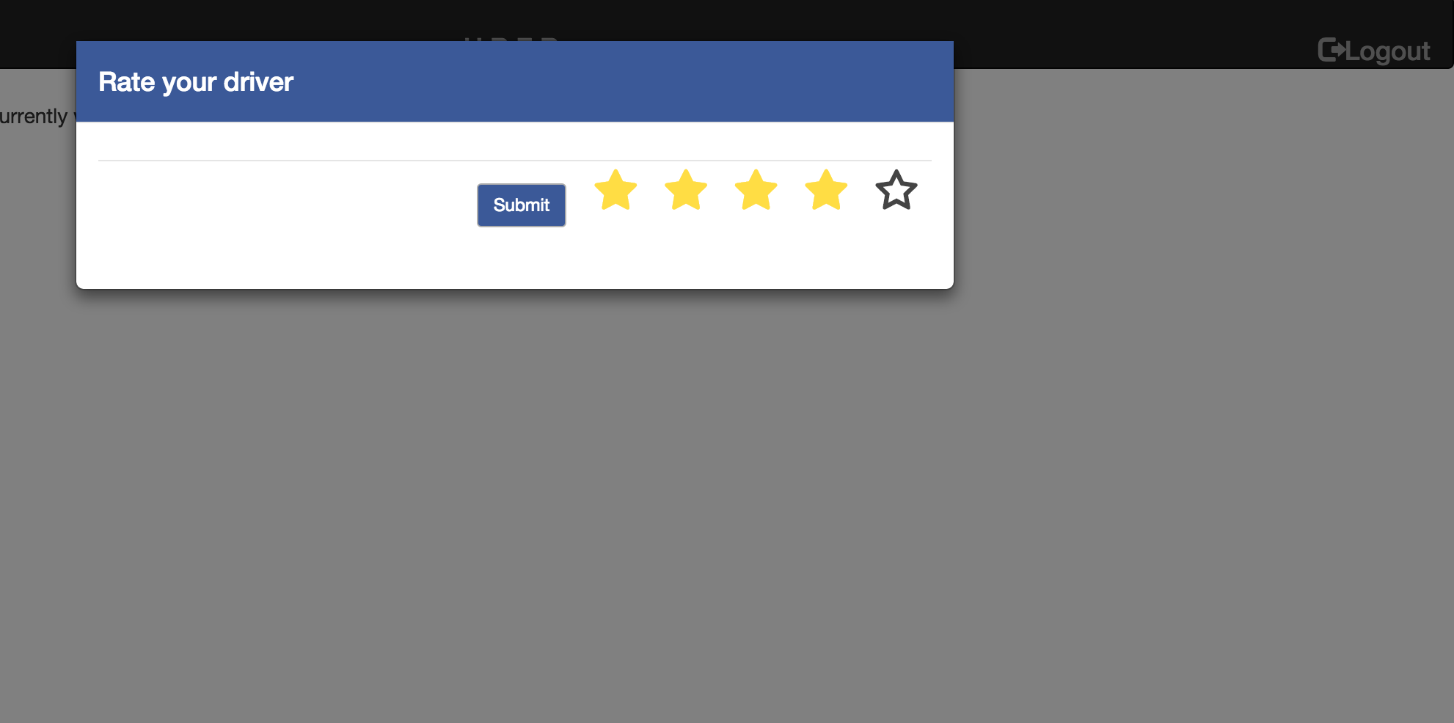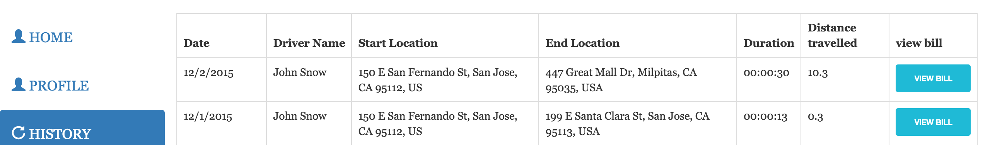

**Help and support Page**

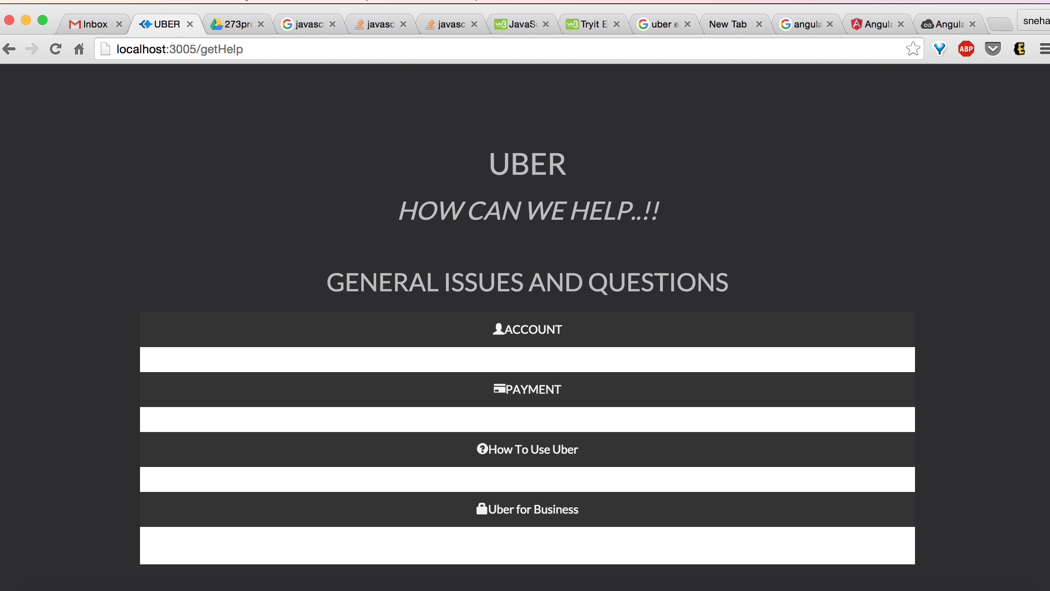

**Driver Search in admin Page**

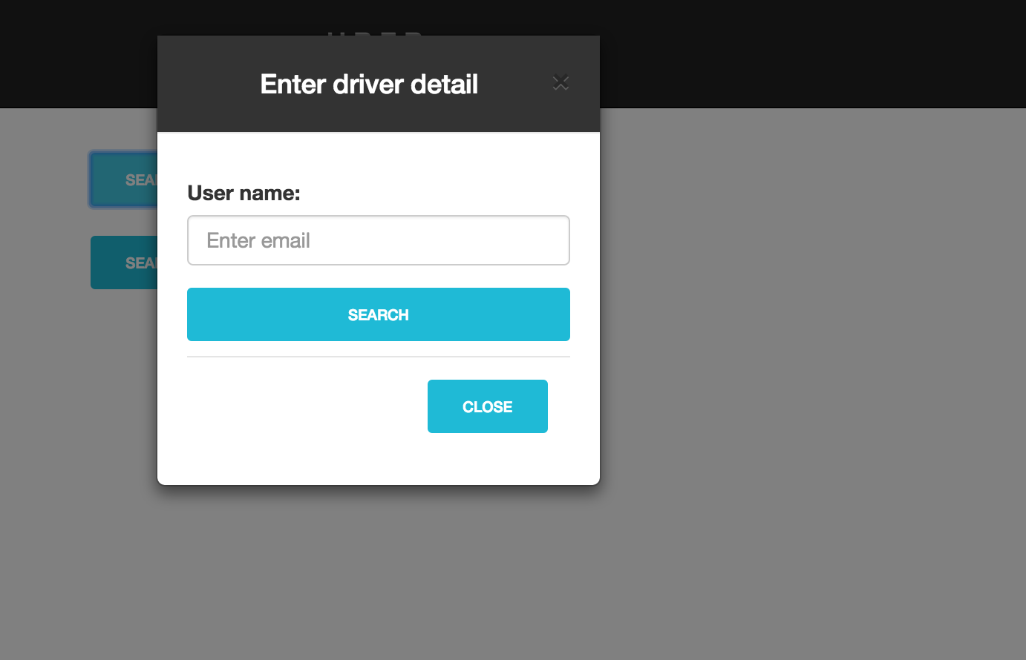

**User profile search in admin page**

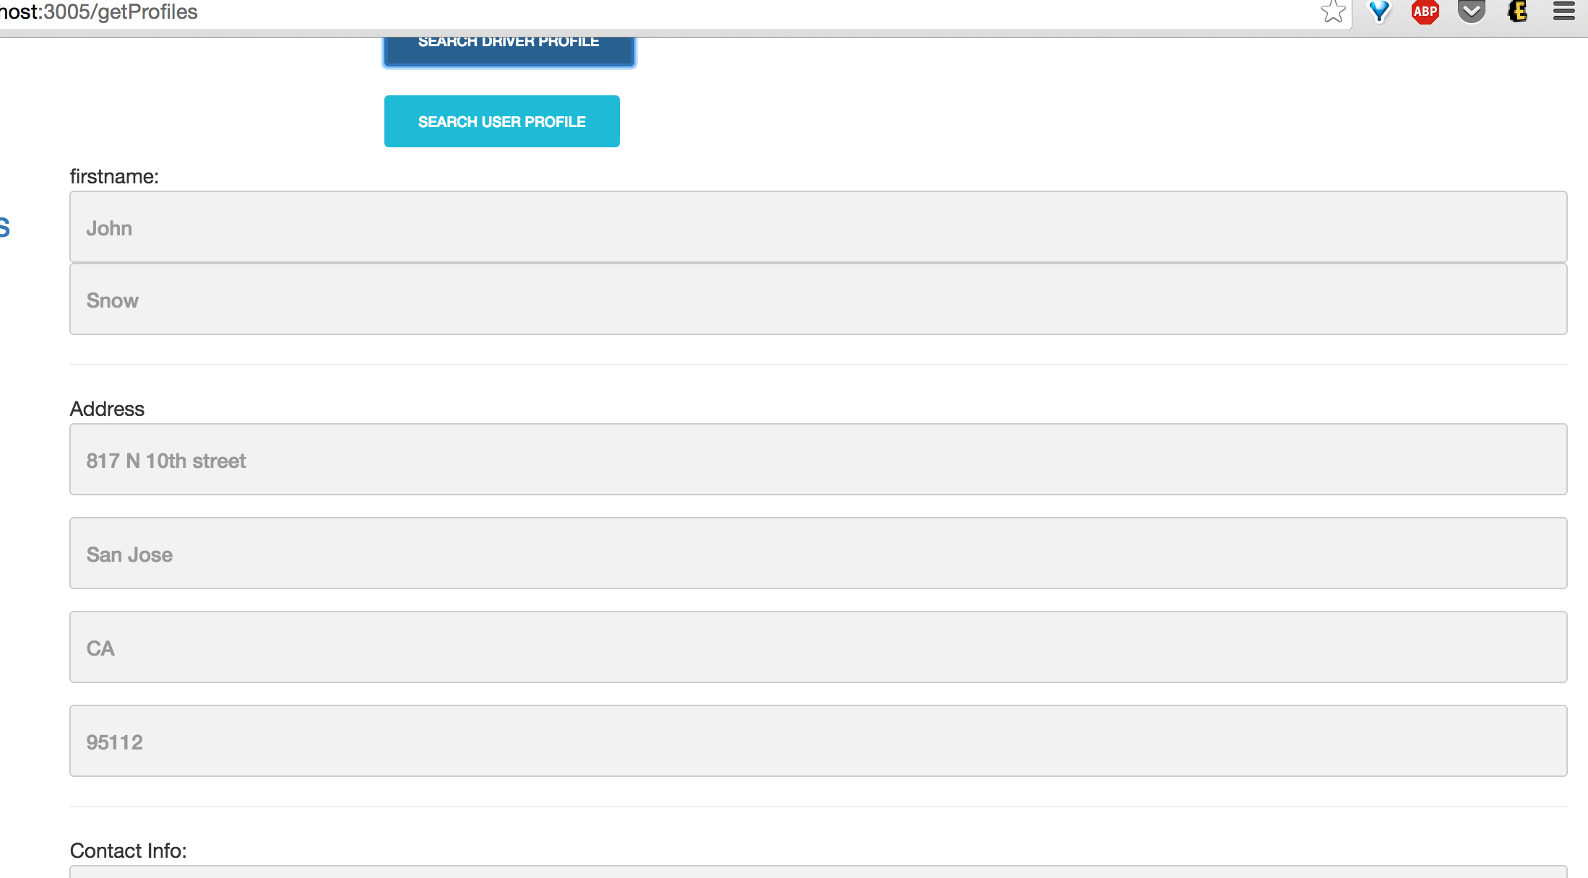

**Search bill in admin page**

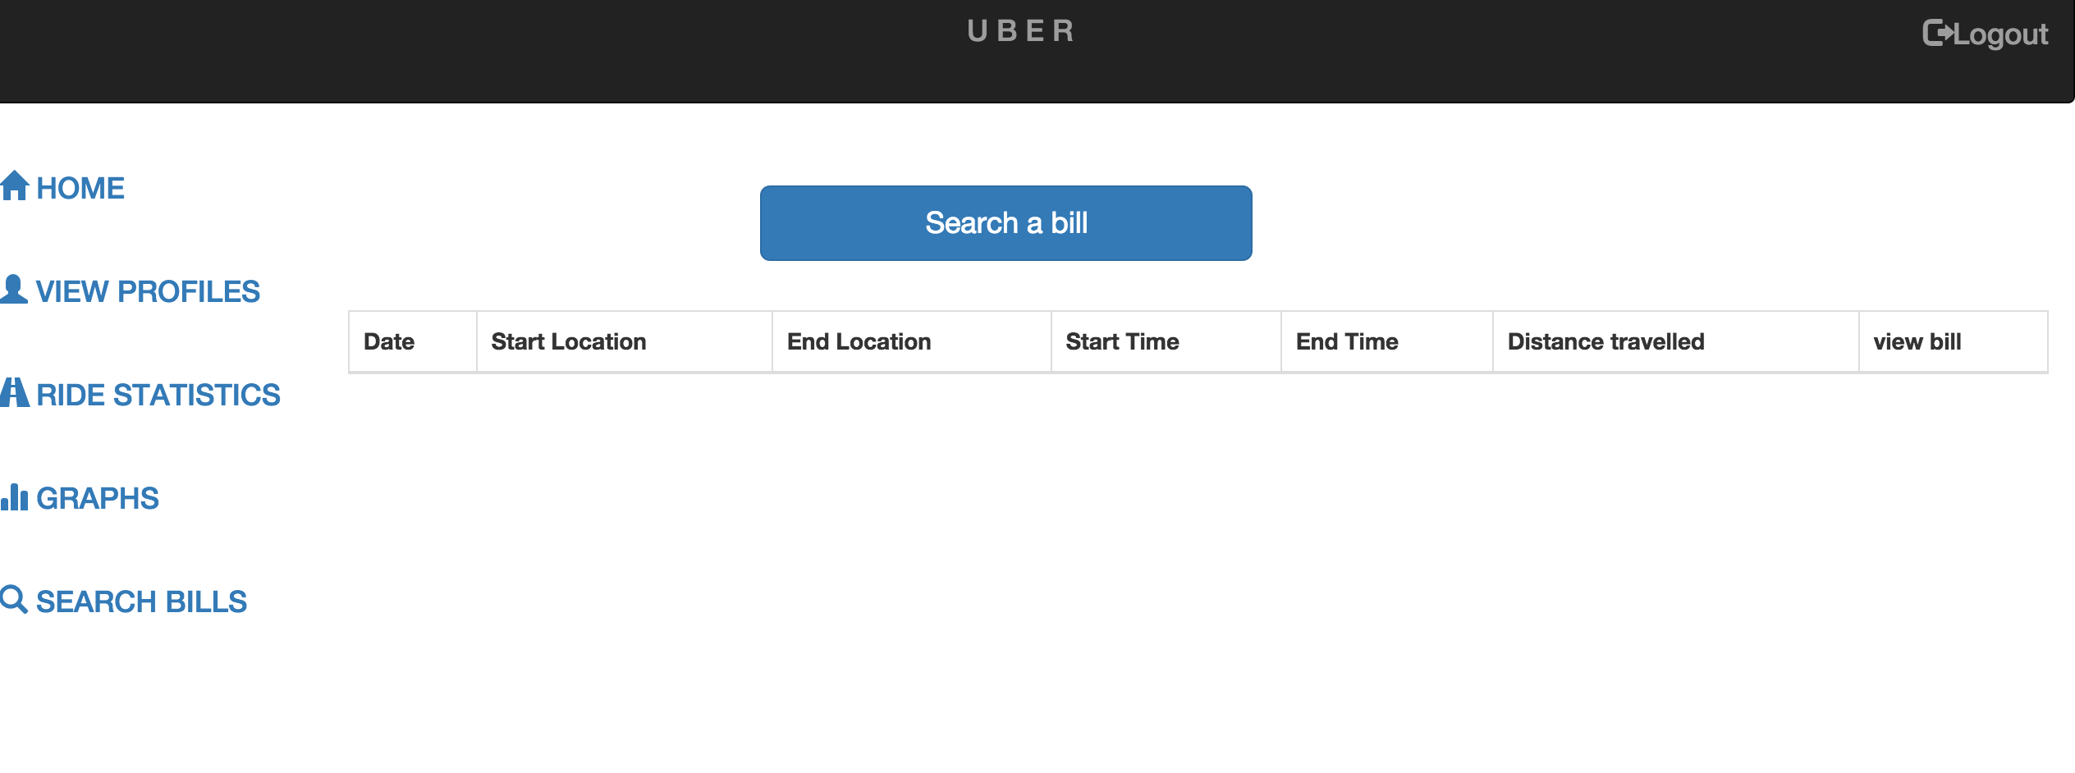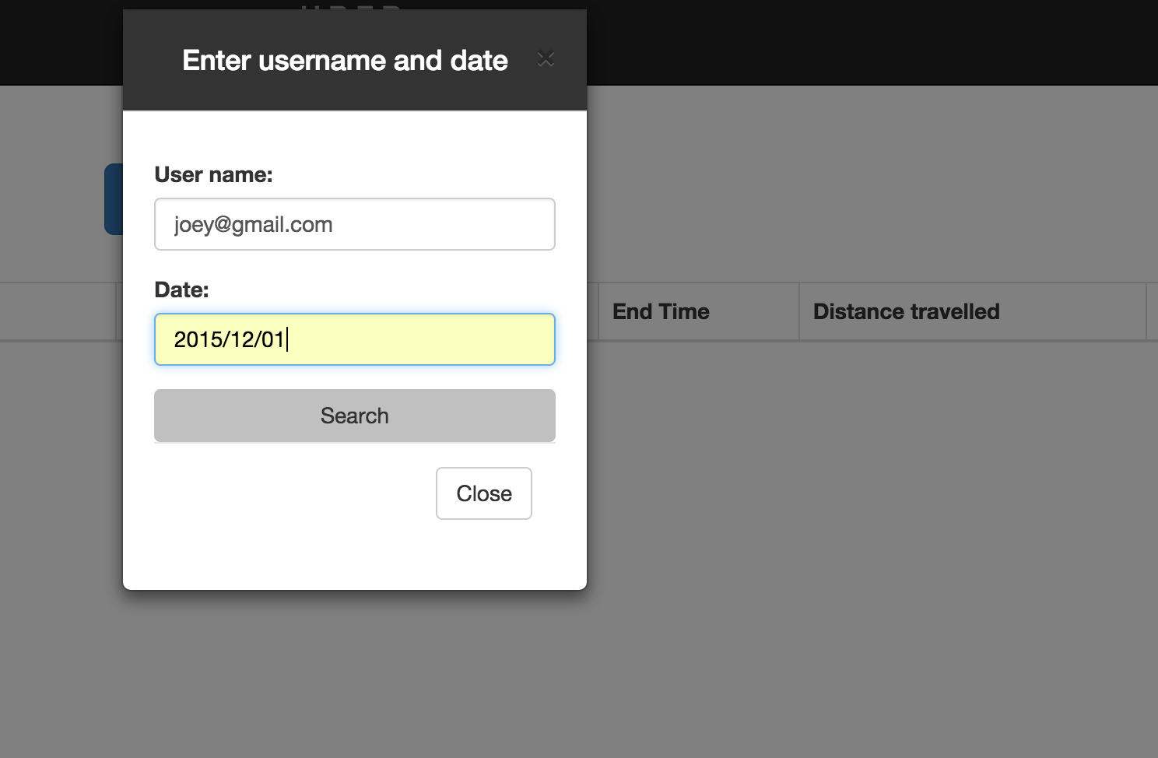

**Admin page view bill**

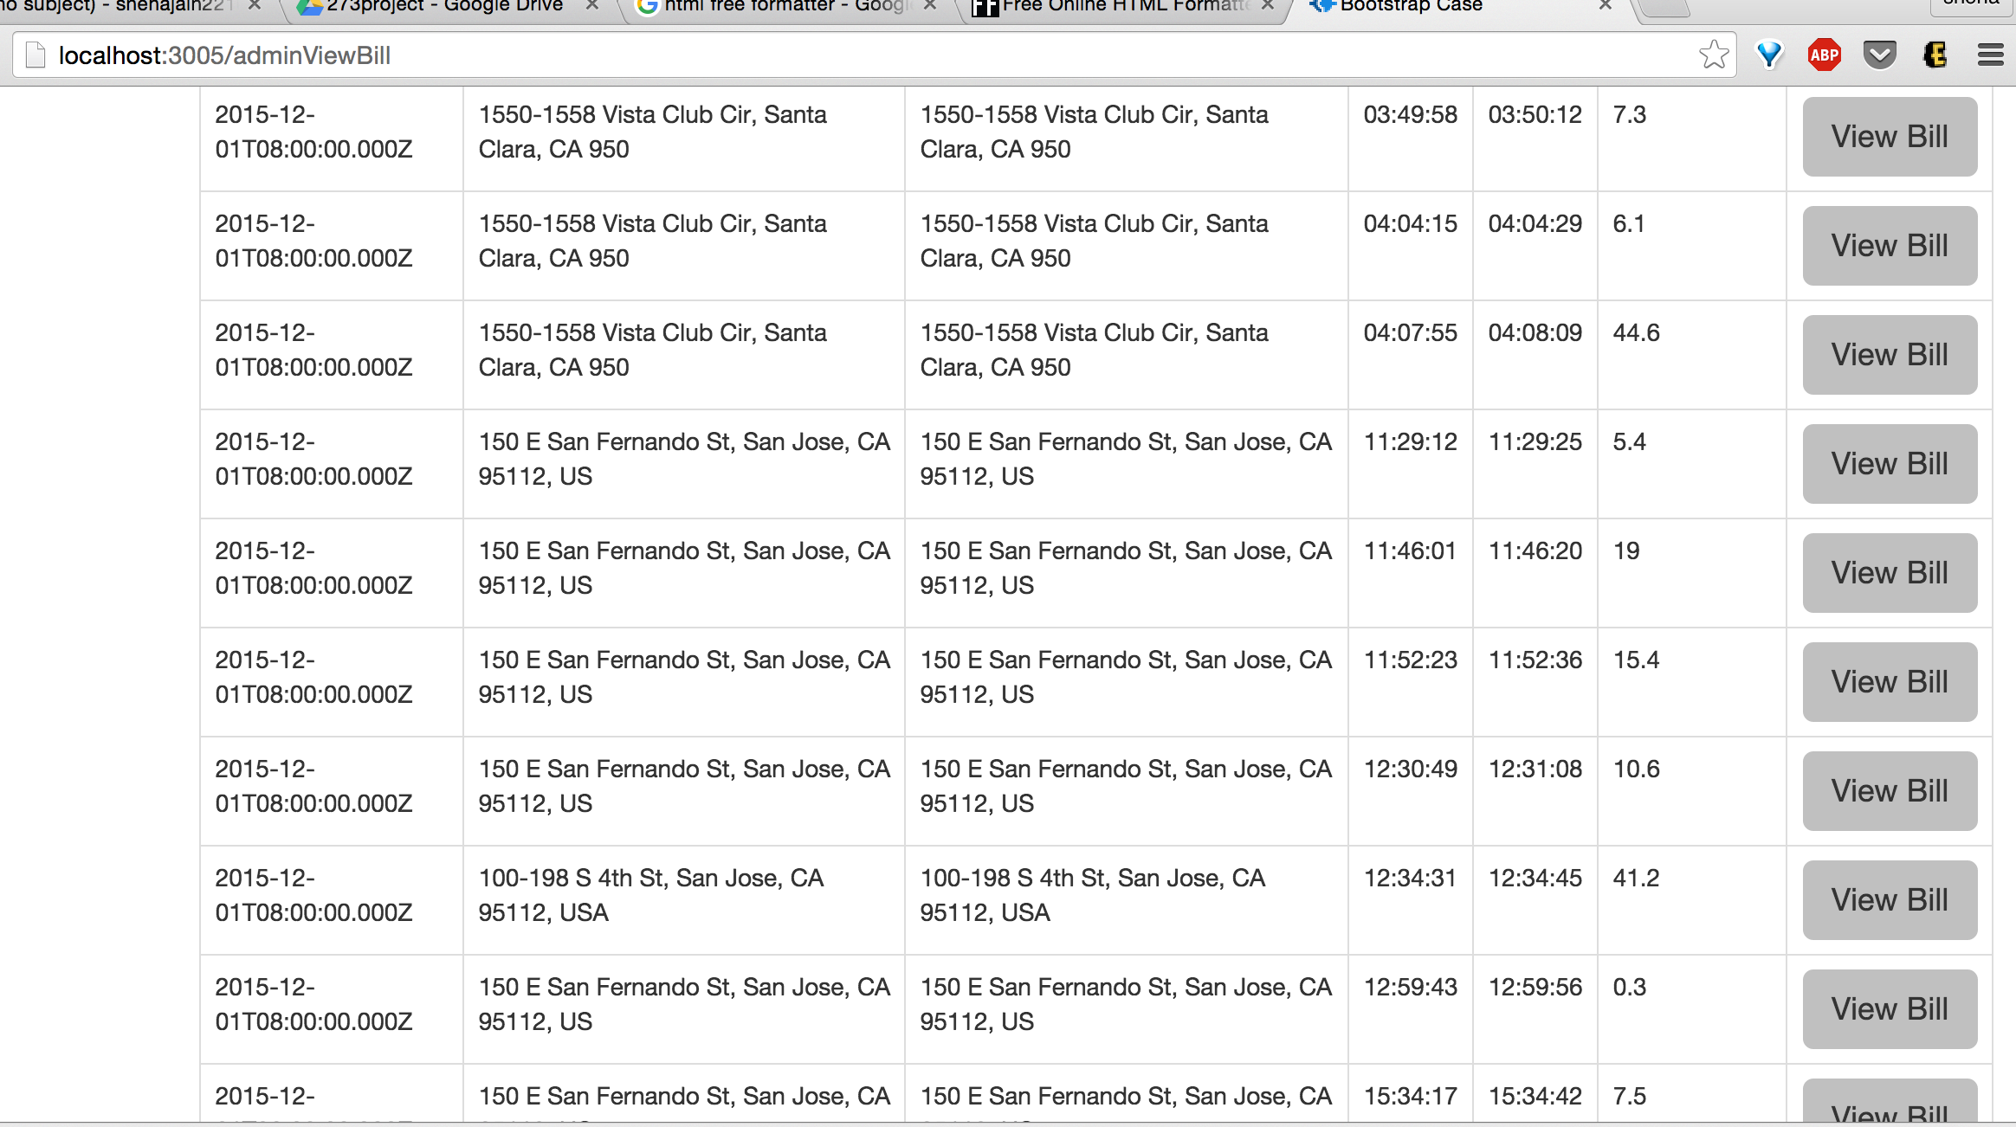

**Admin home page**

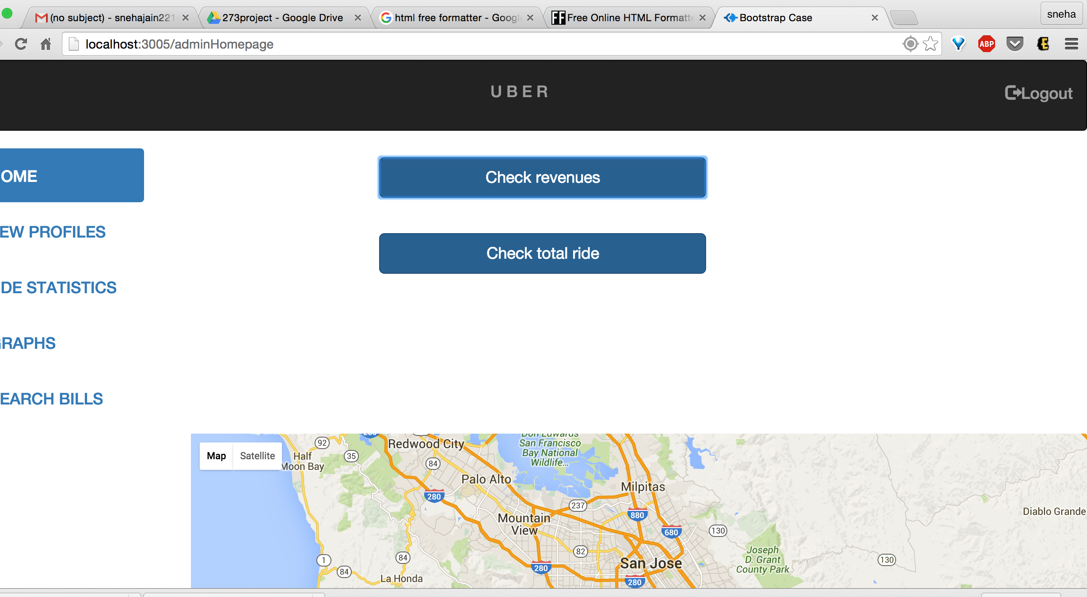

**Revenues report**

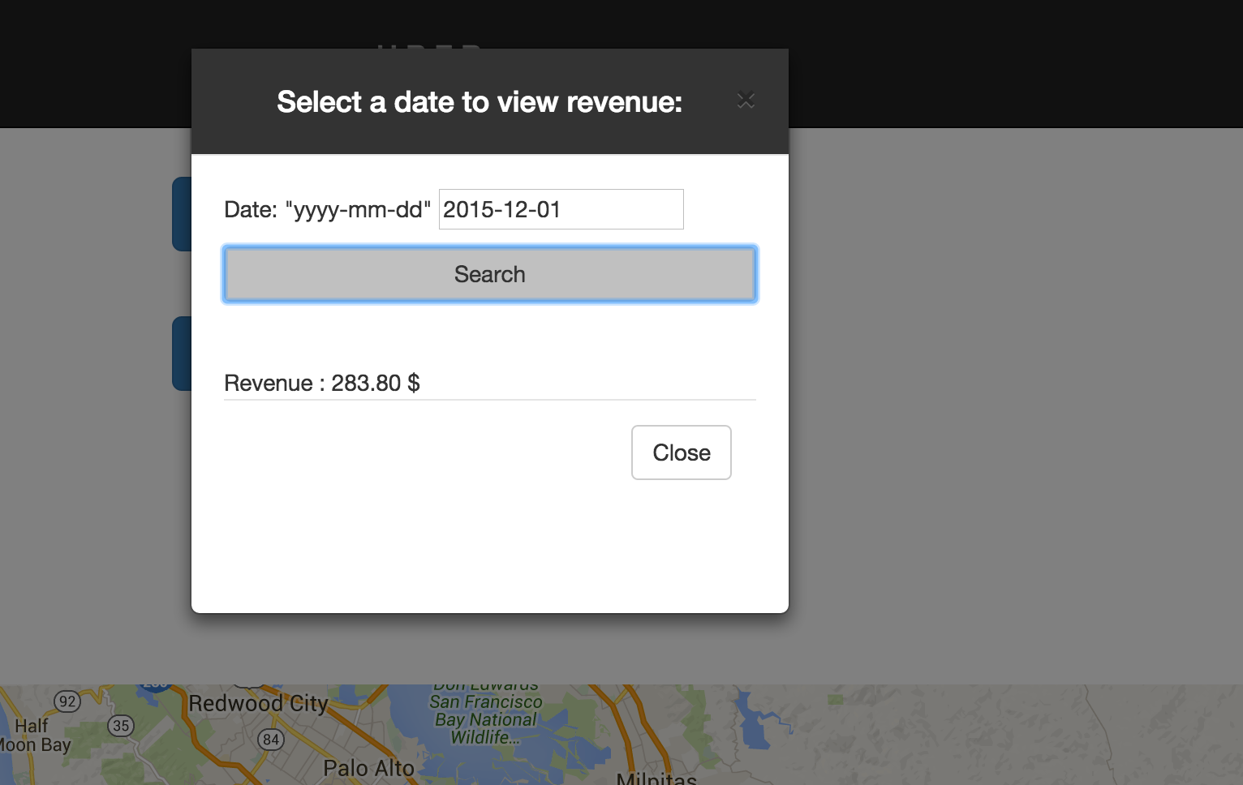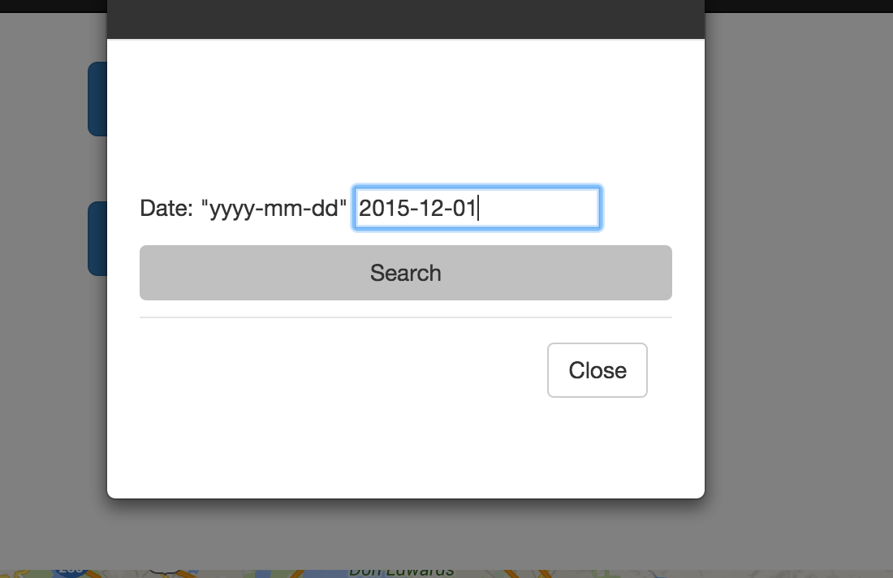

**Displaying all rides for a day for a user.**

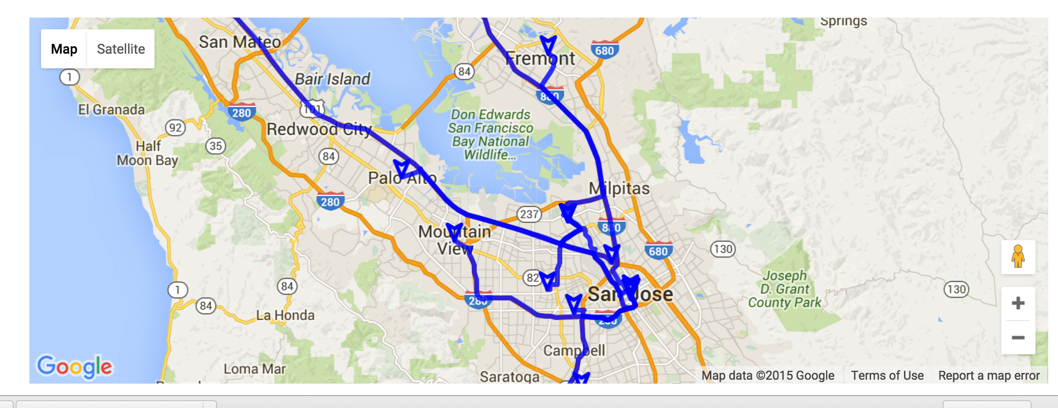

**RabbitMQ Server Queues**

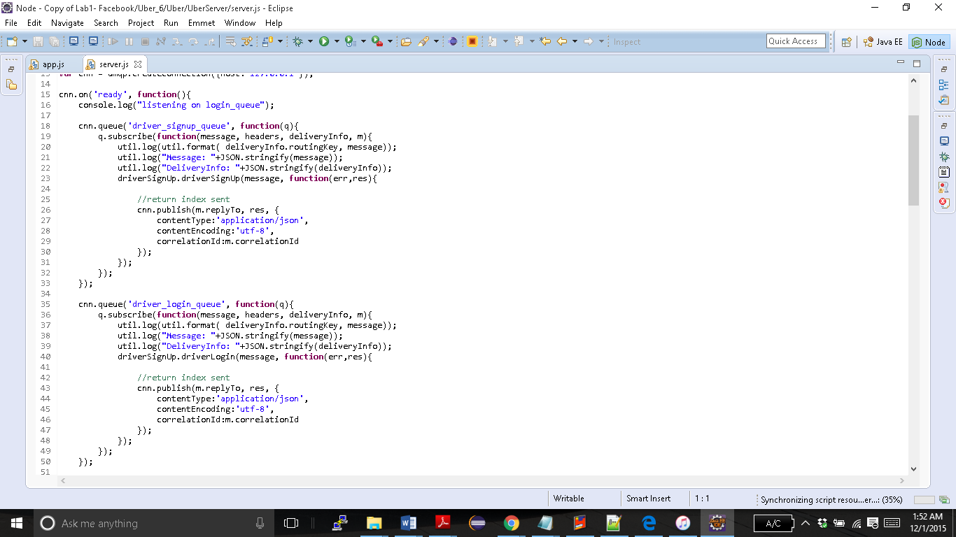

**Server Modules**

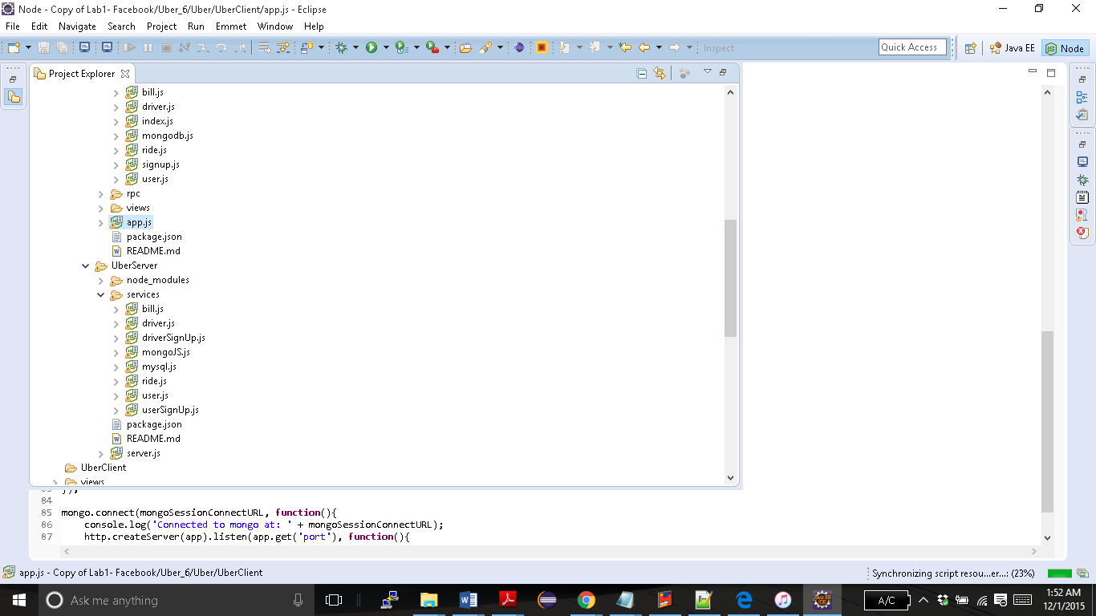

**Performance Data and Graph**

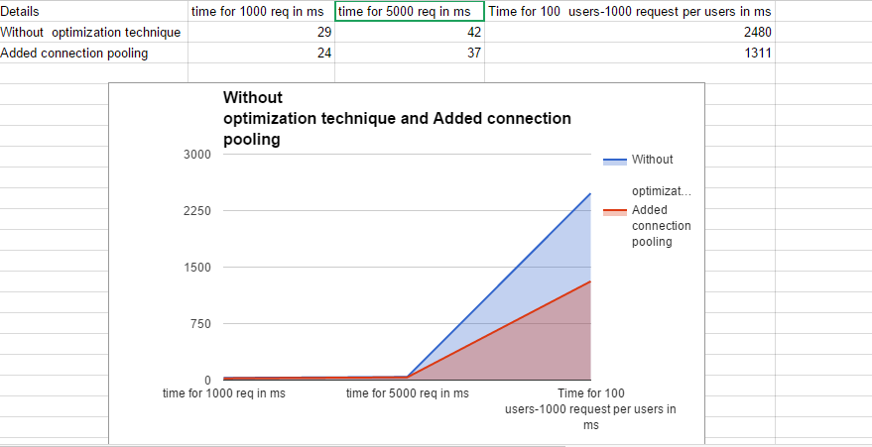

**Client Modules**

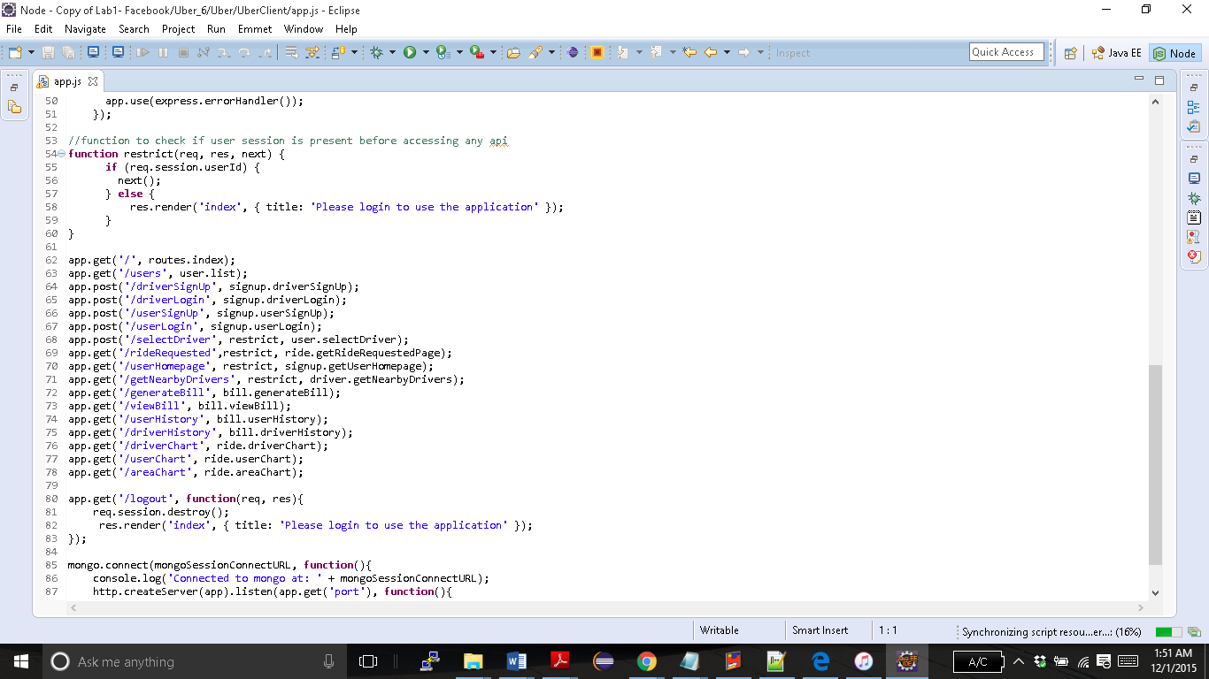

**Connection pooling implementation with MYSQL**

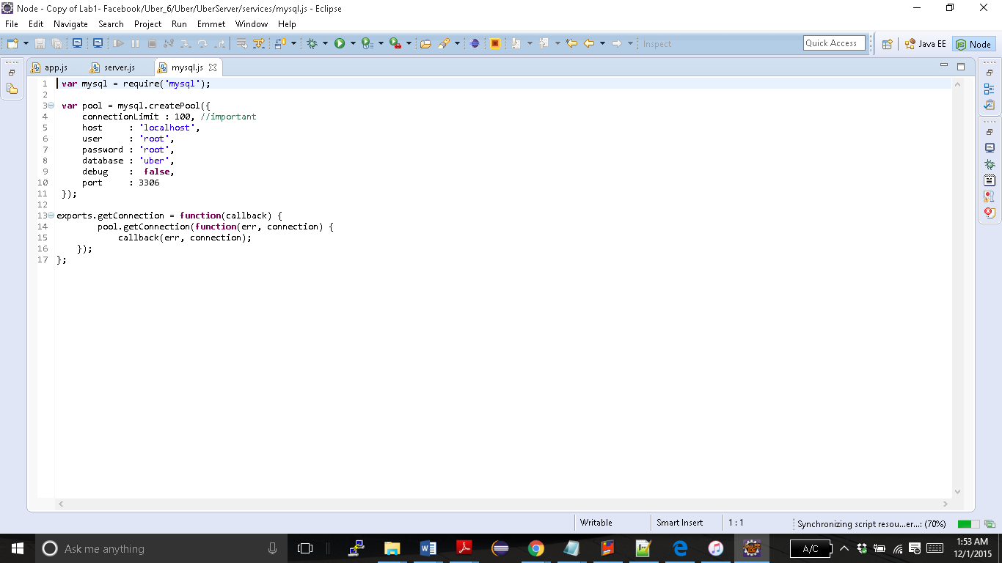

**Mocha Test Cases**

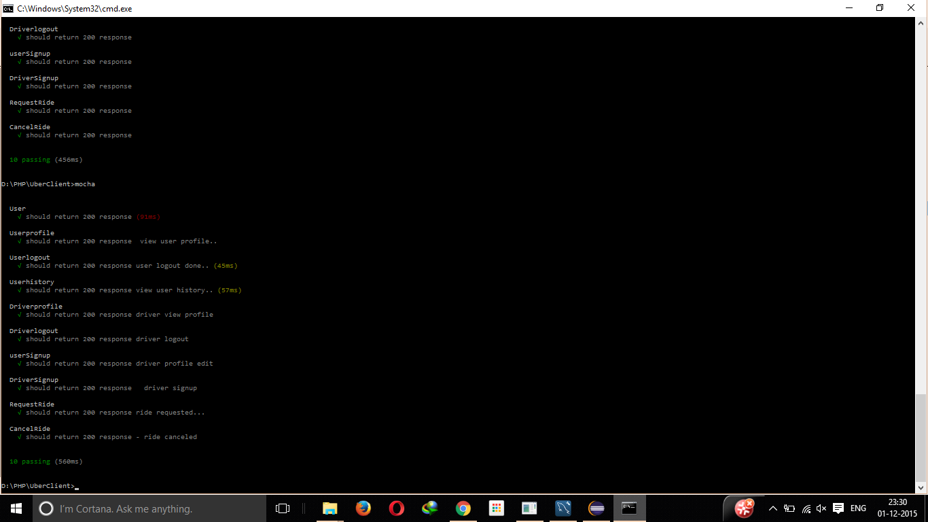

**Performance tuning Techniques**

**1>Connection Pooling**

Connection pooling is one of the most efficient performance technique. It optimizes the time taken to handle requests compared to a system that has independent connections to the database. Accessing the database for each and every query is a time consuming and heavy task that has a major impact on the performance. The Connection pooling algorithm creates a pool of a minimum of 10 connections. When a database query is executed, 1 connection is used instead of creating a new connection to fire the query. The connection is returned back to the pool after the successful execution of the query. So this connection can be reused when another query requires to connect to the database.

**2>RabbitMQ**

RabbitMQ is a highly efficient message passing service that servers request from client to server and delivers a response from the server to the client. By using separate queues for most of the modules that are required to handle heavy loads. The user login, driver login, signup and request rides are some of the modules that have their own separate queues.

**3> Prepared Statements**

Prepared statements are a method to optimize performance by pre storing the query statements in the programs and only inserting the values dynamically. This technique saves precious compute resources and time.

**Contributions of Team Members**

**1>Apoorv Patel**

* Worked on the design and analysis of the system.
* Worked on Driver Login and signup.
* Worked on integration of the modules.
* Worked on the Server application.
* Worked on the Ride module
* Worked with performance optimization Techniques like connection pooling and RabbitMQ.
* Worked on the Driver Module.

**2>Aishwarya Patwardhan**

* Worked on the design and analysis of the system.
* Worked on the client.
* Worked on User signup, login and update modules.
* Worked on the Mocha Test cases.
* Worked with performance optimization Techniques like connection pooling and RabbitMQ
* Worked on rendering maps with Google Maps API.

**3>Shagun**

* Worked on the design and analysis of the system.
* Worked on the client.
* Worked on driver signup, login and update modules.
* Worked on admin page and admin reports.
* Worked with performance optimization Techniques like connection pooling and RabbitMQ
* Worked on rendering maps with Google Maps API.
* Worked on the history module.

**4> Sneha Jain**

* Worked on the design and analysis of the system.
* Worked on the server application.
* Worked on the Client.
* Worked on Request Ride.
* Worked on rendering maps with Google Maps API.
* Worked with Getting Driver List Modules.
* Worked on User History and View Bill Modules.
* Worked with performance optimization Techniques like connection pooling and RabbitMQ

**5>Vishwas Mukund**

* Worked on the design and analysis of the system.
* Worked on User signup, login and update modules.
* Worked on the client.
* Worked on the server application.
* Worked on User History and View Bill Modules.
* Worked on Reporting.
* Worked with performance optimization Techniques like connection pooling and RabbitMQ.

**6>Waad Jaradat**

* Worked on the design and analysis of the system.
* Worked on Request Ride.
* Worked on rendering maps with Google Maps API.
* Worked with Getting Driver List Module.
* Worked on Generate Bills Module.
* Worked with performance optimization Techniques like connection pooling and RabbitMQ
* Worked on admin page and admin reports.

**Our Pricing Algorithm**

We have implemented a clever but simple pricing algorithm that benefits

The users and also is good for maximizing revenue for the company. We have considered many factors and have designed this algorithm.

We have built our algorithm based on some inputs given by real Uber Drivers and their experience with real Uber Cab Service. We designed algorithm from the ground up implements the solution to one of the main challenges faced by Uber in the early days... This problem was, Drivers would go home around 12:00pm to 1:00 am time period but there were a lot of people who needed cabs as it’s the party hours. Many people would like to go home and in most cases cannot drive their own cars as they would be under the influence of Alcohol. So this usually create a massive divide between supply and demand. There simply wasn’t enough drivers to accommodate the Hugh influx of people. Inconveniencing customers is one thing but the company is losing revenue.

So the solution to this problem is that, the multiplier is increased in these peak hours. This financial incentive should be enough to motivate more and more drivers to work during these critical hours.

Also the multiplier is reduced during office hours and School hours, simply because there are enough Uber drivers willing to work in the morning and even the sheer number of customers commuting to get to work and school. So it would indirectly be an incentive to avail our cab service as its competitive pricing.

The time vs pricing model is based on 3 different time periods.

|  |  |  |  |
| --- | --- | --- | --- |
| TIME | 6:00pm-12:00am | 12:00am-6:00am | 6:00am-6:00pm |
| Multiplier Factor | 0.30 | 0.25 | 0.15 |

**How we handle heavyweight resources**

**MongoDB**

MongoDB is the next-generation database that allows creation of applications never before possible. MongoDB is a NoSQL database which can be used to build high-performance systems at scale. The Main advantage of using a NoSQL database is that it is highly scalable and can be used to handle heavy resources.

**RabbitMQ**

RabbitMQ is a message passing service which greatly improves can be used to handle heavyweight resources, since NodeJS is asynchronous and it’s single threaded, I literally waits for 1 task to complete before starting another. So my using message passing each type of request has its own queue or ideally it can even have multiple clones of the queue to handle one type of request. So multiple requests can be simultaneously processed with this kind of installation.

**Connection pooling**

Connection pooling is a technique that can be used to optimize connections to a resource by creating a pool of connections and these are reused. In an increasingly complex program there are massive amount of queries each with its own independent connection to the database, this overloads the database and other related resources. So we use connection pooling which not only optimizes the resources but also takes care of handling a heavy resource by reusing the load.

**Strategy for deciding when to write to database**

We write to the database for the following reasons:

1. If we need to persist the data to be used another time.
2. If the metric that is in question needs to be kept on record for the purpose of logistics.
3. If the values stored in the database needs to be displayed in the front end.
4. All the sensitive data stored in our database is stored in encrypted format.
5. We are also storing images in MongoDB, this saves a lot of disk space.

**Observations and Lessons Learnt**

We learn to design and implement an architecture from requirements analysis to system testing.

NodeJS maybe fast and efficient but this increases the complexity of the program.

* Database operations, performance optimization initially did not work as we expected but we understood the core concept of node and took steps to ensure the functionality.
* The use of call back functions was used to tackle the asynchronistic behaviour of node.
* We learnt to decouple the client and server by the use of a sophisticated message passing algorithm RabbitMQ and developed modules of each API accordingly.
* We established an API framework initially, and we used it as a guideline for the entire project.
* We learnt how to divide the work into divisions so we can work on it individually and then integrate it into our final application.
* We learnt the importance of performance optimization and we incorporated these essential techniques from the ground up.
* We developed an effective test bed using mocha and developed our own test cases to test and validate the various scenarios and use cases in our application.
* We learnt to work together in a team, using effective communication, co-ordination and documentation.